


S-129
Published by the
International Hydrographic Organization
4b quai Antoine 1er
Principauté de Monaco
Tel: (377) 93.10.81.00
Fax: (377) 93.10.81.40
info@iho.int
www.iho.in
Under Keel Clearance Management Product Specification

Edition 2.0.1 – July 2026

© Copyright International Hydrographic Organization 2024
This work is copyright. Apart from any use permitted in accordance with the Berne Convention for the Protection of Literary and Artistic Works (1886), and except in the circumstances described below, no part may be translated, reproduced by any process, adapted, communicated or commercially exploited without prior written permission from the International Hydrographic Organization (IHO). Copyright in some of the material in this publication may be owned by another party and permission for the translation and/or reproduction of that material must be obtained from the owner.
This document or partial material from this document may be translated, reproduced or distributed for general information, on no more than a cost recovery basis. Copies may not be sold or distributed for profit or gain without prior written agreement of the IHO Secretariat and any other copyright holders.
In the event that this document or partial material from this document is reproduced, translated or distributed under the terms described above, the following statements are to be included:
“Material from IHO publication [reference to extract: Title, Edition] is reproduced with the permission of the IHO Secretariat (Permission No ……./…) acting for the International Hydrographic Organization (IHO), which does not accept responsibility for the correctness of the material as reproduced: in case of doubt, the IHO’s authentic text shall prevail. The incorporation of material sourced from IHO shall not be construed as constituting an endorsement by IHO of this product.”
“This [document/publication] is a translation of IHO [document/publication] [name]. The IHO has not checked this translation and therefore takes no responsibility for its accuracy. In case of doubt the source version of [name] in [language] should be consulted.”
The IHO Logo or other identifiers shall not be used in any derived product without prior written permission from the IHO Secretariat.

Document Control
Changes to this Product Specification are coordinated by the IHO S-100 Working Group. New editions will be made available via the IHO web site. Maintenance of the Product Specification must conform to IHO Resolution 2/2007as amended.
Version Number | Date | Author | Purpose
0.1.0 draft |  | S-129 PT | Initial draft
0.2.0 draft | 18 Sep 18 | S-129 PT | S-129 PT Meeting 3 (Busan, Republic of Korea) – output draft
0.3.0 draft | 29 Oct 18 | S-129 PT | Post S-129 Meeting 3 with additional input from PT
0.4.0 draft | 3 Dec 18 | S-129 PT | For out of session review by other IHO working groups
0.5.0 draft | 08 Feb 19 | S-129 PT | For review by S-100WG and S-129 PT
0.5.1 | 26 Feb 19 | S-129 PT | Updates made at S-100WG meeting 27-29 Feb 19
0.6.0 | 8 Mar 19 | S-129 PT | Clean version post S-100WG meeting of 27-29 Feb 19 for final IHO Secretariat editorial makeover
1.0.0 | Jun 2019 | S-129 PT | First Edition for implementation and testing purposes
1.1.0 | Nov 2023 | S-129 PT | Revision based on 5^{th,} 6th, and 7th S-129 PT meeting outcomes and PS validation in Tjeldsundet S-129 Operational Test. Other identified corrections also applied.
1.2.0 | Jul 2024 | S-129 PT | Revision based on changes in line with S-100 Edition 5.2.0, and clarified usage of S-421 for passage route information.  Other corrections and updates.
1.3.0 | Sep 2024 | S-129 PT | Revision based on comments made to S-129 Edition 1.2.0
2.0.0 | Oct 2024 | S-129 PT | Changes based on comments made to S-129 Edition 1.3.0
2.0.1 | July 2027 | S-129 PT

Page intentionally left blank

Contents
Document Control iii
Summary of Substantive Changes vii
1 Overview 1
1.1 Introduction 1
1.2 Initial voyage planning to navigate through a UKCM Operational Area 1
1.3 Refined voyage planning to navigate through a UKCM Operational Area 1
1.4 Voyage monitoring 2
1.5 Alerts and Indications 3
2 References 3
2.1 Normative 3
3 Terms, Definitions and Abbreviations 4
3.1 Use of Language 4
3.2 Terms and Definitions 4
3.3 Abbreviations 6
4 Specification Description 6
4.1 S-129 General Data Product Description 6
4.2 Data Product Specification Metadata 7
4.3 IHO Product Specification Maintenance 8
5 Specification Scope 8
6 Dataset Identification 9
7 Data Content and Structure 9
7.1 Introduction 9
7.2 Application Schema 13
8 Feature Catalogue 22
8.1 Introduction 22
8.2 Feature Types 23
8.3 Units of measure 24
9 Dataset Types 24
10 Dataset Loading and Unloading 24
11 Geometry 25
12 Coordinate Reference Systems (CRS) 25
12.1 Introduction 25
12.2 Horizontal Reference System 25
12.3 Vertical Reference System 25
12.4 Temporal Reference System 25
13 Data Quality 26
13.1 Introduction 26
14 Data Capture and Classification 26
15 Maintenance 26
15.1 Maintenance and Update Frequency 26
15.2 Data Source 27
15.3 Production Process 27
16 Portrayal 27
17 Data Product Format (Encoding) 27
17.1 Encoding of Latitude and Longitude 27
17.2 Numeric Attribute Encoding 28
17.3 Text Attribute Values 28
17.4 Mandatory Attribute Values 28
17.5 Unknown Attribute Values 28
17.6 Structure of dataset files 28
17.7 Object identifiers 29
17.8 Dataset validation 29
17.9 Data overlap 29
17.10 Data quality 29
18 Data Product Delivery 29
18.1 Introduction 29
18.2 Dataset 31
18.3 Data Integrity 32
18.4 Support Files 32
19 Metadata 33
19.1 Introduction 33
19.2 Use of S-421 to provide routes in UKC plans 34
19.3 Language 34
19.4 Dataset metadata 34
19.5 S100_ExchangeCatalogue 37
19.6 S100_DatasetDiscoveryMetadata 38
19.7 S100_SupportFileDiscoveryMetadata 43
19.8 S100_CatalogueDiscoveryMetadata 44
Annex A. Data Classification and Encoding Guide 47
A.1 UnderKeelClearancePlan 47
A.2 UnderKeelClearancePlanArea 48
A.3 UnderKeelClearanceNonNavigableArea 49
A.4 UnderKeelClearanceAlmostNonNavigableArea 50
A.5 UnderKeelClearanceControlPoint 51
A.6 Association Names 52
A.7 Association Roles 53
A.8 Attribute and Enumerate Descriptions 53
Annex B. Schema documentation for S129.xsd 59
B.1 Schema(s) 59
B.2 Complex Type(s) 59
B.3 Simple Type(s) 73
Annex C. Feature Catalogue 75
C.1 Catalogue header information 75
C.2 Definition Sources 76
C.3 Simple Attributes 77
C.4 Enumerations 82
C.5 Complex Attributes 84
C.6 Roles 85
C.7 Feature Types 87
Annex D. Portrayal Catalogue 91
D.1 Catalogue header information 91
D.2 Definition Sources 92
D.3 Color Profiles 93
D.4 Symbols 94
D.5 Line styles 96
D.6 Area Fills 97
D.7 Fonts 98
D.8 Viewing Group 99
D.9 Viewing Group Layer 100
D.10 Context 100
D.11 Rules 101
Annex E. Data Validation Checks 103
Annex F. Geometry 105
F.1 Introduction 105
F.2 Geometric Operator Definitions 107

Summary of Substantive Changes

Bold references in the Clauses Effected column indicate the principle sections/clauses that are impacted by the described change.
Change Summary | Clauses Affected
Figure 1-1 updated to remove conflicting route line depiction. | 1.1
Added paragraph to clarify the differences between S-129 and safety contours. | 1.1
Added explicit note that coordinate order must be latitude followed by longitude. | 12.1
Updated Data Quality chapter to more closely align with recommendations as per S-97 Part C, Clause C-7. | 13
Removed incorrect/redundant paragraph and example pertaining to coordinate encoding as decimals | 17.1.1
References to file sizes updated to use binary prefixes | 18.1, 18.2.2
Amendments/additions to subclauses under Clause 18.2 to clearly distinguish new datasets and new editions of datasets. | 18.2.1.1, 18.2.1.2
Amendments/additions to subclauses under Clause 18.2 to clearly dataset cancellation methods | 18.2.1.3
Dataset file naming convention updated to allow up to 64 characters, restricted to using alphanumerical characters (A-Z, a-z, 0-9), hyphen, and underscore | 18.2.3
Subclause added to outline support files for S-129 | 18.3
intereoperabilityIdentifier multiplicity updated to [0..*] | 7.2.1.1, 7.2.1.2, 7.2.1.3, 7.2.1.4, 7.2.1.5, A.1, A.2, A.3, A.4, A.5, C.7.1, C.7.2, C.7.3, C.7.4, C.7.5
GM_Curve references removed, as not usd in S-129 | B.2.2
Corrected inconsistent enumeration labels | C.4.1
Corrected role name theCollection | C.6.2
Updated DIAMOND1P symbol description in line with update in IHO GI Registry. | D.4.4
Removed redundant/unused Viewing Group references | D.8.5, D.8.6
Added/updated rule descriptions to reflect transition to LUA portrayal | D.11

Page intentionally left blank

Overview

Introduction
The IHO’s S-100 Working Group has prepared this document in response to a requirement to produce a dataset comprising Under Keel Clearance Management (UKCM) information that can be used as a Nautical Publication Information Overlay (NPIO) within an Electronic Chart Display and Information System (ECDIS). It is based on the IHO’s S-100 framework specification and the ISO 19100 series of standards.
S-129 is a vector Product Specification intended for encoding the UKCM information products for navigational purposes. Use of UKCM products conformant to this specification is not limited to navigation systems.
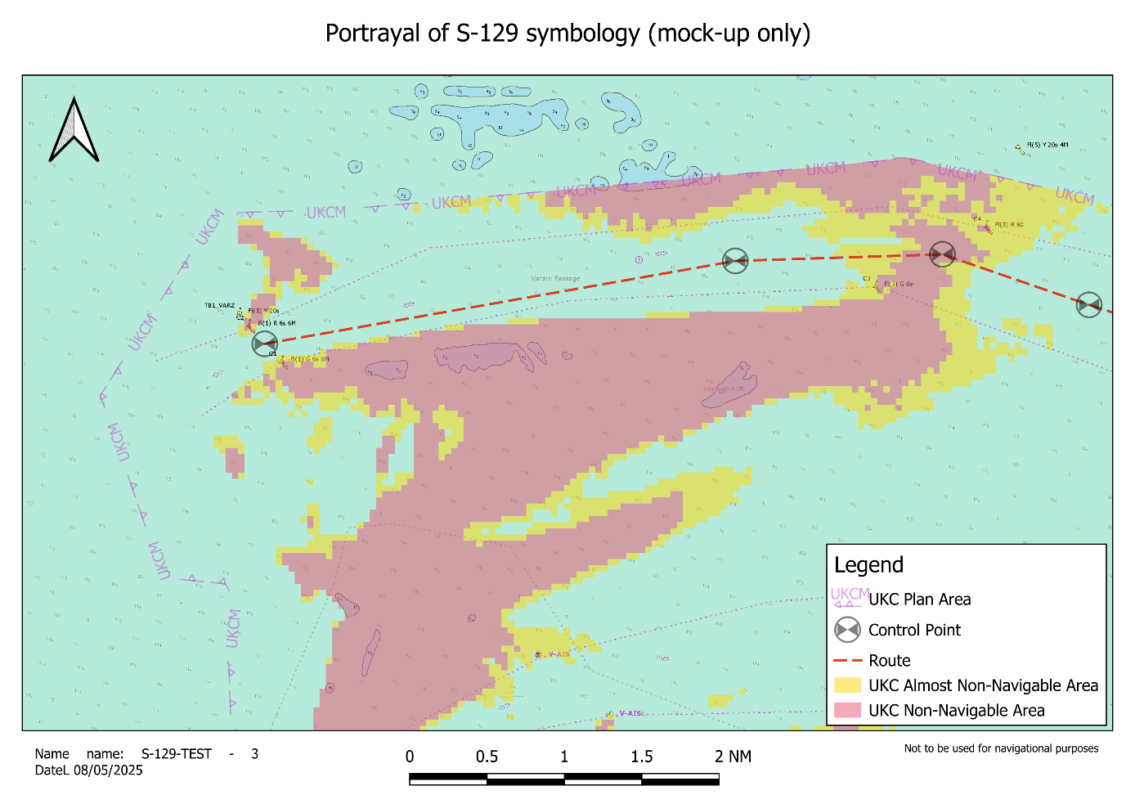
Figure 1-1 – Example of S-129 UKCM information depiction
A ship’s master has an obligation under SOLAS regulation V/34 to plan their ship’s voyage from berth to berth. This Product Specification enables UKCM information to be provided to users of a UKCM Service.
S-129 is intended to support maritime domain awareness, voyage planning and decision support by providing dynamic or context-specific UKCM information. It is distinct from, and does not replace, the Safety Contour or Enhanced Safety Contour functionality of the ECDIS. While Safety Contours and Enhanced Safety Contours are computed on board within the ECDIS and reflect static UKC allowances, S-129 can present passage- and vessel-specific, dynamic UKC information. S-129 datasets can comprise predicted UKC based on parameters such as planned or actual passage timing, route, speed, loading condition and hull form, as well as environmental predictions and observations. S-129 also supports UKC predictions that can be projected ahead of the vessel, such that the displayed information represents the anticipated UKC along the planned voyage, rather than at a single point in time as indicated by the Safety Contour. Thus, where available, S-129 enhances passage planning and decision support. S-129 datasets may be generated by shore-side UKCM services employing validated models and complex computations, and the resulting information may be updated regularly in response to changes in external inputs or passage plan updates.

Initial voyage planning to navigate through a UKCM Operational Area
A ship planning its voyage needs to determine the time periods when there are suitable tidal conditions for it to transit a UKCM Operational Area. A UKCM Service Provider completes calculations based on a range of possible arrival times to determine a Pre-plan, which contains one or more time windows for a specified draught for a ship’s master to choose from.

Refined voyage planning to navigate through a UKCM Operational Area
A ship’s master selects a time window to transit through a UKCM Operational Area and advises the UKCM Service Provider. A ship also sends the UKCM Service Provider updated information about its particulars (for example stability and draught information). The UKCM Service Provider uses specialized ship and waterway-specific modelling that includes predicted and observed environmental conditions (for example tide, wind, swell, tidal stream, etc.) to generate an Actual Plan for a ship.
An Actual Plan contains a route for the ship to take through the UKCM Operational Area and one or more control points. Control points are, in effect, waypoints and include time window information. An Actual Plan provides the ship with the necessary navigation information to safely pass through the UKCM Operational Area at a given time. The Actual Plan also includes any relevant non-navigable areas and almost non-navigable areas.
To facilitate logistics planning, the Actual Plan can be shared with other parties, such as the ship’s owners, management company, charterers, or the ship’s agent at the relevant port. For example, it can be used to provide information that assists the ship’s agent and relevant waterway authorities with making necessary bookings, such as for a pilot or for a berth.
As the ship nears the UKCM Operational Area, the UKCM Service Provider checks the prevailing environmental conditions within the UKCM Operational Area and confirms the validity of the Actual Plan. The Actual Plan may alter due to changes in predicted weather forecasts, heights of tide, or the ship’s particulars. The Actual Plan might be replaced (using an Actual Update) when changes are required. This checking process allows the ship to manage its speed to meet the required time window to execute the Actual Plan.
The Actual Update contains details of the earliest and latest times at which the ship can safely commence navigating shallow areas in the UKCM Operational Area while maintaining the required UKC (note that waterway authorities specify minimum UKC requirements for ships operating within a UKCM Operational Area). The Actual Update also includes any relevant non-navigable areas and almost non-navigable areas within the UKCM Operational Area.

Voyage monitoring
When the ship enters the UKCM Operational Area, the Actual Update can be displayed on the ship’s navigation system. When a pilot is embarked, they will, generally, be using a Portable Pilot Unit (PPU) that also shows the ship’s UKC plan (as this is also provided to the pilot by the UKCM Service Provider). Having the same information displayed on both the ship’s navigation system and the pilot’s PPU helps a ship’s crew support the pilot navigating the ship through a UKCM Operational Area, while maintaining the required UKC.
The UKCM Service Provider receives transmitted ship AIS data which allows them to send Actual Update datasets that contain the updated UKC plan metadata, non-navigable areas, almost non-navigable areas, and, if necessary, new versions of the route and control points, based on the ship’s speed and the current environmental conditions.
The ship’s crew and the pilot (when embarked) are able to monitor, in real-time or near real-time, areas that have been calculated as non-navigable and almost non-navigable on their on-board navigation systems. The areas shown as almost non-navigable indicate to the ship’s bridge team and the pilot (when embarked) the navigable areas that are close to becoming non-navigable at the time the ship would reach those locations.
If a Vessel Traffic Service (VTS) is in operation for the UKCM Operational Area, the VTS can monitor the ship’s transit and support navigation in accordance with the Actual Plan and/or Actual Update, which it has been provided with.
In port settings, after the ship has completed its cargo operations, and if the ship’s draught is such that the local area UKCM system must be used to exit the port, then the UKCM Service Provider would, similarly, be used to assist the ship’s safe departure from the port through the UKCM Operational Area.

Alerts and Indications
The intent behind the inclusion of the S-129 product as an information layer within the IHO’s S-100 framework is to enhance navigational awareness without introducing additional complexity or operational risks. S-129, which provides mariners with a depiction of UKC ‘go’ and no-go’ areas for a given route and time, offers valuable situational data that complements other navigational products like S-101 and S-102/S-104. However, to ensure that this supplementary information does not inadvertently overload the user or cause unnecessary confusion, the S-129 layer is designed to be non-intrusive, providing visual information only, without triggering any alarms. This approach maintains a clear separation between crucial navigational alarms and non-essential data displays, ensuring that mariners can prioritize safety-critical alerts.
The decision not to have S-129 trigger any alarms is also based on the need to preserve the integrity and reliability of existing Electronic Chart Display and Information System (ECDIS) alarms generated via S-101 for ENC data and the combined alarms produced from bathymetric and water level information in S-102/S-104. If the S-129 layer were to issue alarms, it could interfere with or mask more critical alarms required for safe navigation, leading to potential navigational errors or delayed responses. Therefore, by providing S-129 as an information layer only, the system ensures a cleaner, more intuitive user experience without diminishing the operational importance of other safety-related ECDIS functions.

References

Normative
The following normative documents contain provisions that, through reference in this text, constitute provisions of this document.
IHO S-100 IHO Universal Hydrographic Data Model, Edition 5.2.0 – June 2024
IHO S-101 IHO Electronic Navigational Chart (ENC) Product Specification
IHO S-102 IHO Bathymetric Surface Product Specification
IHO S-104 IHO Water Level Information for Surface Navigation Product Specification
IEC 63173-1 S-421 route plan based on S-100
IHO S-52 IHO Specifications for Chart Content and Display Aspects of ECDIS Edition 6.1.1 – October 2014 (with clarifications up to June 2015)
ISO 10646:2017 Information technology – Universal Coded Character Set (UCS)
+Amd1 (2017) and Amd2 (2017)
ISO/IEC 15948 Information technology – Computer graphics and image processing – Portable Network Graphics (PNG): Functional specification
ISO 19101:2014 Geographic information – Reference model
ISO 19103:2015 Geographic information – Conceptual schema
ISO 19107:2003 Geographic information – Spatial schema
ISO 19108:2002 Geographic information – Temporal schema
+Corr1 (2006)
ISO 19109:2005 Geographic information – Rules for application schema
ISO 19110:2016 Geographic information – Methodology for feature cataloguing
ISO 19111:2003 Geographic information – Spatial referencing by coordinates
+Corr1 (2006)
ISO 19115-1:2014 Geographic information – Metadata Part 1: Fundamentals
+Amd1 (2018)
ISO 19117:2012 Geographic information – Portrayal
ISO 19125-1:2004 Geographic information – Simple feature access – Part 1: Common Architecture
ISO 19136:2007 Geographic information – Geography Markup Language (GML)
ISO 19136-2:2015 Geographic information – Geography Markup Language (GML)
ISO/IEC 8211:1994 Information technology – Specification for a data descriptive file for information exchange
ISO 8601-1:2019 Date and time – Representation for information interchange – Part 1: Basic rules
ISO 8601-2:2019 Date and time – Representation for information interchange – Part 2: Extensions
ISO 639-2:1998 Codes for the representation of names of languages – Part 2: Alpha-3 code

Terms, Definitions and Abbreviations

Use of Language
Within this document:
- “Must” indicates a mandatory requirement.
- “Should” indicates an optional requirement, that is the recommended process to be followed, but is not mandatory.
- “May” means “allowed to” or “could possibly”, but is not mandatory.

Terms and Definitions
The S-100 framework is based on the ISO 19100 series of geographic standards. The terms and definitions provided here are used to standardize the nomenclature found within that framework, whenever possible. They are taken from the references cited in Clause 2.1. Modifications have been made where necessary.
Actual Plan
An Actual Plan is specific to a ship and a UKCM Operational Area for a waterway, and contains a route – defined by a set of geographical control points – with time windows for each control point, and non-navigable and almost non-navigable areas.
Actual Update
An Actual Update is a replacement Actual Plan.
Almost non-navigable area
An area within a UKCM Operational Area where UKC for a specific ship is calculated to be approaching the UKC limit for the waterway (within a specified value range).
Control Point
A geographical position denoting a point along a specific ship’s route within a UKCM Operational Area where the ship must pass within a time range or time window (that is, start and end time) calculated by the UKCM Service Provider.
Coordinate
One of a sequence of n numbers designating the position of a point in n-dimensional space.
NOTE: In a coordinate reference system, the coordinate numbers are qualified by units.
Coordinate Reference System
Coordinate system that is related to an object by a datum.
NOTE: For geodetic and vertical datums, the object will be the Earth.
Feature
Abstraction of real-world phenomena.
NOTE 1: A feature may occur as a type or an instance. Feature type or feature instance should be used when only one is meant.
NOTE 2: In UML 2, a feature is a property, such as an operation or attribute, which is encapsulated as part of a list within a classifier, such as an interface, class, or data type.
[ISO 19101, ISO/TS 19103, ISO 19110]
Feature Attribute
Characteristic of a feature.
NOTE 1: A feature attribute may occur as a type or an instance. Feature attribute type or feature attribute instance is used when only one is meant.
NOTE 2: A feature attribute type has a name, a data type, and a domain associated to it. A feature attribute instance has an attribute value taken from the domain of the feature attribute type.
NOTE 3: In a feature catalogue, a feature attribute may include a value domain but does not specify attribute values for feature instances.
EXAMPLE 1: A feature attribute named colour may have an attribute value green which belongs to the data type text.
EXAMPLE 2: A feature attribute named length may have an attribute value 82.4 which belongs to the data type real.
Navigation Surface
A data object representing the bathymetry and associated uncertainty with the methods by which those objects can be manipulated, combined and used for a number of tasks, certified for safety of navigation.
Non-navigable Area
An area within a UKCM Operational Area where UKC for a specific ship is calculated to be less than the UKC limit for the waterway.
Pre-plan
A Pre-plan is a set of tidal windows available for which a ship can transit through a UKCM Operational Area at a specified draught while satisfying minimum UKC requirements.
Sea Surface
A two-dimensional (in the horizontal plane) field representing the air-sea interface, with high-frequency fluctuations such as wind waves and swell (but not astronomical tides) filtered out.
NOTE: This implies marine water, lakes, waterways, navigable rivers, etc.
EXAMPLE: sea surface, river surface, lake surface.
UKC Plan
There are three kinds of UKC plans: a Pre-plan, an Actual Plan, and an Actual Update.
UKCM Operational Area
The geographic area in which a UKCM Service is in operation and for which UKCM information can be provided.
UKCM Service
An aid to navigation which contributes to navigational safety and efficiency. It uses data modelling which may include detailed bathymetry, predicted and real-time environmental data, and ship particulars and motion, to provide a ship-specific, real-time information and/or forecast information for a given time and waterway.
UKCM Service Provider
A UKCM Service Provider is an entity responsible for implementing, providing, and maintaining a UKCM Service. Its role involves producing and disseminating under keel clearance (UKC) information, which enhances navigational safety and efficiency within a designated port of waterway where a UKCM Operational Area has been established.

Abbreviations
This Product Specification makes use of the following abbreviations:
AIS Automatic Identification System
BAG Bathymetric Attributed Grid
ECDIS Electronic Chart Display and Information System
ENC Electronic Navigational Chart
GML Geography Markup Language
IEC International Electrotechnical Commission
IHO International Hydrographic Organization
ISO International Organization for Standardization
UKC Under Keel Clearance
UKCM Under Keel Clearance Management
UML Unified Modelling Language
UTC Coordinated Universal Time

Specification Description

S-129 General Data Product Description
General data product information.
Title: UKCM Information Product Specification

Abstract: UKCM Services are generally used in conjunction with ENC (S-101) and route information for aiding ships in safe passage through shallow waters. S-421 Route Exchange Data Format, if available, is considered the preferred method for providing route information. This S-129 UKCM Product Specification details the information typically provided by a UKCM Service Provider.

Content: A conformant data product contains features associated with UKCM. The specific content is defined by the Feature Catalogue and the Application Schema.

Spatial Extent:

Description: Global coverage of maritime areas.

Purpose: The data shall be produced for the purposes of UKCM.

Data Product Specification Metadata
NOTE: This information uniquely identifies this Product Specification and provides information about its creation and maintenance. For further information on dataset metadata, see the metadata clause (Chapter 19 - Metadata).
Title: The International Hydrographic Organization Under Keel Clearance Management Product Specification
S-100 Version: 5.2.0
S-129 Version: 2.0.1
Date: July 2026
Language: English
Classification: Unclassified
Contact: International Hydrographic Organization,
4b quai Antoine 1er,
B.P. 445
MC 98011 MONACO CEDEX
Telephone: +377 93 10 81 00
Telefax: +377 93 10 81 40
Email: info@iho.int
URL: www.iho.int
Identifier: S-129
Maintenance: Changes to the Product Specification S-129 are coordinated by the IHO S-100 Working Group (S-100WG) and must be made available via the IHO web site. Maintenance of the Product Specification must conform to IHO Technical Resolution 2/2007, as amended.

IHO Product Specification Maintenance

Introduction
Changes to S-129 will be released by the IHO as a New Edition, a revision, or as a document that includes clarification. These are described below.

New Editions
New Editions introduce significant changes. New Editions enable new concepts, such as the ability to support new functions or applications, or the introduction of new constructs or data types. New Editions are likely to have a significant impact on either existing users or future users of S-129. All cumulative revisions and clarifications must be included with the release of approved New Editions.

Revisions
Revisions are defined as substantive semantic changes. Typically, revisions will introduce changes to correct factual errors; introduce necessary changes that have become evident as a result of practical experience or changing circumstances. A revision must not be classified as a clarification. Revisions could have an impact on either existing users or future users of this specification. All cumulative clarifications must be included with the release of approved corrections revisions.
Changes in a revision are minor and ensure backward compatibility with the previous versions within the same Edition. Newer revisions, for example, introduce new features and attributes. Within the same Edition, a dataset of one version could always be processed with a later version of the feature and portrayal catalogues.
In most cases, a new feature or portrayal catalogue will result in a revision of this specification.

Clarifications
Clarifications are non-substantive changes. Typically, clarifications: remove ambiguity; correct grammatical and spelling errors; amend or update cross references; insert improved graphics in spelling, punctuation and grammar. A clarification must not cause any substantive semantic changes.
Changes in clarifications are minor and ensure backward compatibility with the previous versions within the same Edition. Within the same Edition, a dataset of one clarification version could always be processed with a later version of the feature and portrayal catalogues, and a portrayal catalogue can always rely on earlier versions of the feature catalogues.

Version Numbers
The associated version control numbering to identify changes (n) to S-129 must be as follows:
New Editions denoted as n.0.0
Revisions denoted as n.n.0
Clarifications denoted as n.n.n

Specification Scope
This Product Specification describes one product and therefore requires only one scope.
Scope ID: Under Keel Clearance Management datasets
Hierarchical level: MD_ScopeCode – 005
Hierarchical level name: Dataset
Level description: Information applies to the datasets
Extent: EX_Extent.description: Global coverage of maritime areas

Dataset Identification
This section describes how to identify datasets that conform to this Product Specification. An Under Keel Clearance Management dataset that conforms to this Product Specification uses the following general information for distinction:
Title: Under Keel Clearance Management
Abstract: The dataset is a file containing under keel clearance data for a particular geographic region and set of times, along with the accompanying metadata describing the content, variables, applicable times and locations, and structure of the dataset. Under keel clearance management data includes vessel and voyage specific areas assessed as being navigationally safe or unsafe with regard to under keel clearance, and windows within which these assessments are valid, based upon observed and/or mathematically-predicted values. The frequency of dataset updates depends on the voyage and local conditions.
Acronym: UKCM
Geographic Description: EX_GeographicDescription: For example, official name of region
Spatial Resolution: MD_Resolution>equivalentScale.denominator (integer) or MD_Resolution>levelOfDetail (CharacterString). For example, “All scales”
Purpose: Under keel clearance management data is intended to be used as a layer in an ENC
Language: EN
Additional values, if any, use CharacterString values from ISO 639-2
Classification: Unclassified
Additional values, if any, use CharacterString values from ISO 639-2
Point of Contact: CI_Responsibility
Use Limitation: Invalid over land

Data Content and Structure

Introduction
This section discusses:
- the application schema expressed in UML 2,0, shown in Figure 7-2. S-129 Data Model;
- the associated feature catalogue (included in Annex C);
- the dataset types, providing a full description of each feature type including its attributes, attribute values and relationships in the dataset;
- the geometry of each feature type, where applicable
- dataset loading and unloading; and
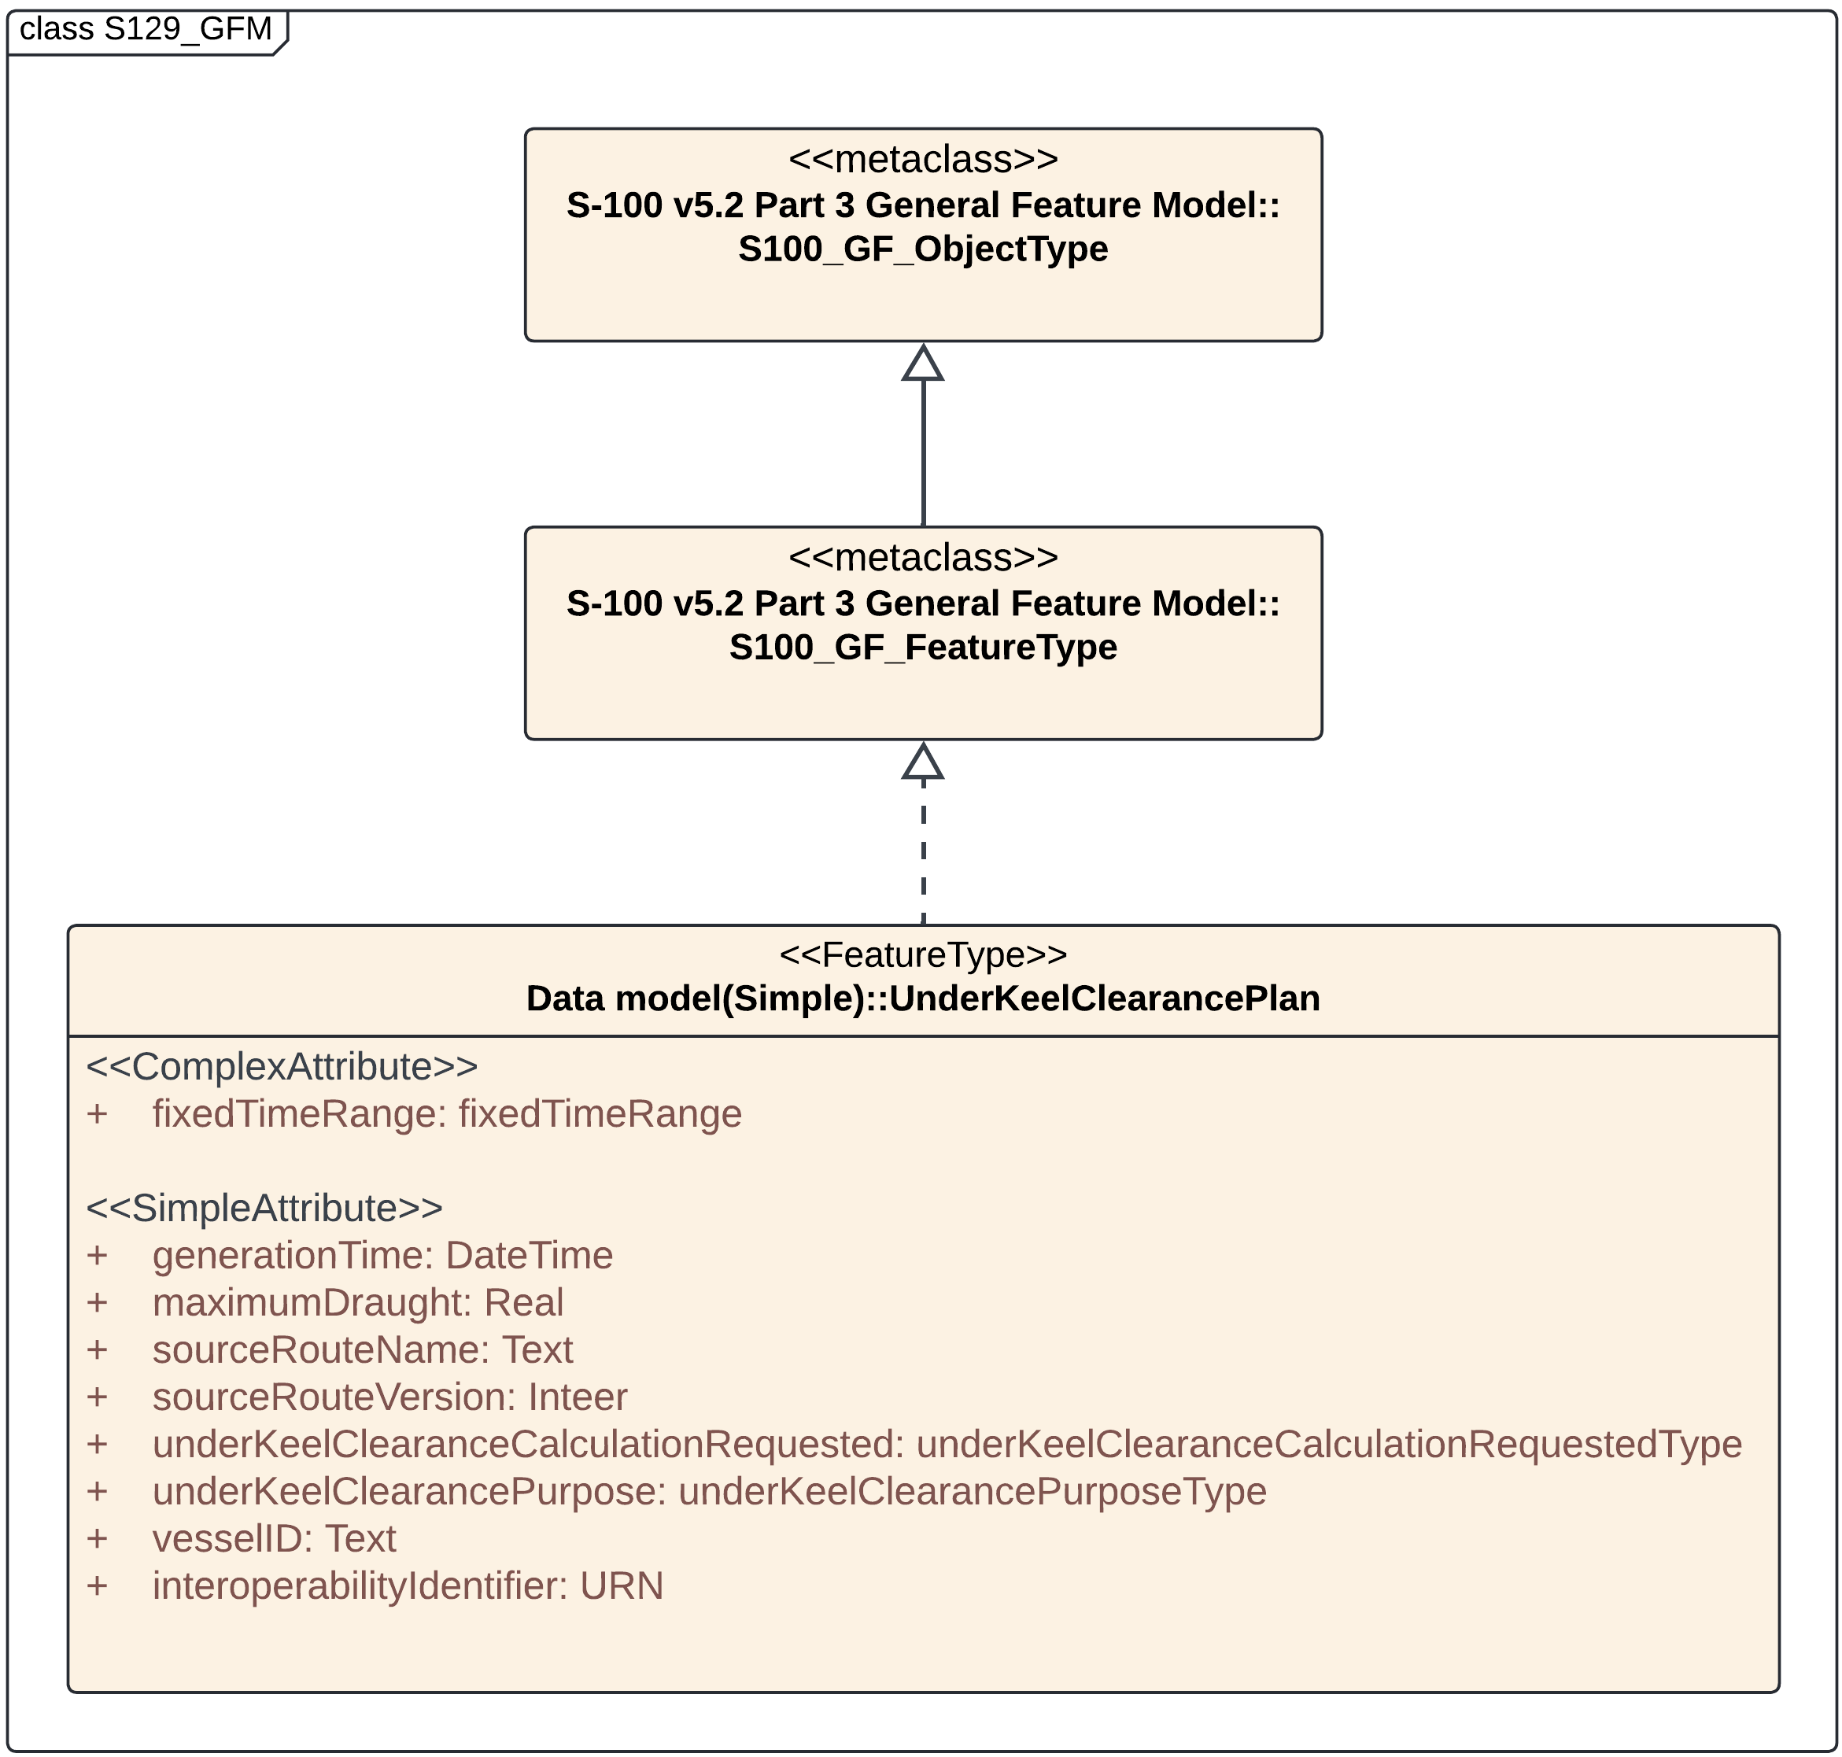
Figure 7-1 – Relationship between S-100 meta class and S-129 application schema
The S-129 features are based on the S-100 General Feature Model (GFM) and are a feature-based vector product. Figure 7-1 shows the relations between the S-129 Application Schema and the S-100 GFM.
All S-129 features are derived from the feature UnderKeelClearancePlan defined in the S-129 Application Schema and this UnderKeelClearancePlan realizes the GFM meta-classes S100_GF_FeatureType.
S-129 datasets are generally intended to be used with S-101 ENC, and optionally with S-102 (Bathymetric Surface), S-104 (Water Level Information for Surface Navigation), or S-111 (Surface Currents) datasets. S-101 provides the background information, while S-129 datasets provide additional information related specifically to UKCM. S-129 datasets are also intended to be used with S-421, if available, to provide passage route information. When S-421 datasets are unavailable, alternative methods, such as RTZ route plan exchange format, can be used to provide passage route information.
Dataset content will change over time during a ship’s transit. Updating datasets is achieved by replacement. The attribute “underKeelClearancePurpose” captures the intended purpose of a dataset. The possible values are ‘Pre-plan’, ‘Actual Plan’ and ‘Actual Update’.

Dataset purposes

Pre-plan datasets
Pre-plan datasets are used in voyage pre-planning and will produce for a ship a set of tidal windows for an arrival port or waterway, for a specified draught, days or weeks in advance. In this case, it is likely that the UKCM Service will simply compute tidal windows based on water level and current forecast models, other weather statistics and a standard assumed route.

Actual Plan datasets
Actual Plan datasets are produced closer to the arrival/departure (for example, 24 hours prior) and provide the mariner (crew and/or pilot) with a more detailed passage plan. This plan is generated from more frequent and/or precise weather forecasts/observations.

Actual Update datasets
Actual Update datasets include more up-to-date information and may be required every five to ten minutes. These datasets include the route, the under keel clearance plan area, almost non-navigable areas, and non-navigable areas under the 'parent' UnderKeelClearancePlan feature. The dataset will be updated based on the latest weather conditions and, if available, actual ship position, heading and speed (for example as received by a UKCM Service Provider via a ship’s transmitted AIS signal).

Dataset use cases
UKCM datasets are updated by whole dataset replacement. Which data needs to be updated, and how frequently, depends on the purpose of UKC calculation (as indicated by the 'underKeelClearancePurpose' attribute). The following is a typical updating scenario, but variations may exist depending on local circumstances.
In the pre-planning use case, a ship requests a set of tidal windows for an arrival/departure port or waterway, for a specified draught, days or weeks in advance. In this case, the UKCM Service may compute a tidal window based on predicted tides, forecast navigable depths, including safety/manoeuvrability margins, ship maximum draught, speed and squat predictions, other forecast environmental conditions and a standard assumed route. In this scenario, the UKCM Service could return a single Pre-plan dataset, and generally no updates are required until closer to the time when the ship enters the UKCM Operational Area (for example, approximately 24 hrs prior to entry).
Closer to the time of a ship entering the UKCM Operational Area (for example, 24 hours prior), the ship will need a more detailed UKC plan. This Actual Plan usually considers more up to date information and will typically need to be updated more frequently. In this case, the non-navigable and almost non-navigable areas, any tidal windows (via Control Points), and some metadata will have changed. Depending on the variability of the met-ocean conditions, the update frequency could vary, for example between 10 and 60 minutes.
Immediately before entering the UKCM Operational Area and whilst underway, the use case changes again to become the Actual Update. Throughout the Actual Plan phase, more up-to-date UKC information is required, provided more frequently than Actual Plan datasets (for example, every five to ten minutes). In this case, it is likely that the whole information in the dataset needs to be updated – including the route, the almost non-navigable areas, non-navigable areas, and the 'parent' UnderKeelClearancePlan feature. The dataset will be updated based on latest observed and forecast conditions, and (optionally) actual ship position, heading and speed (for example as received in a UKCM Service via AIS). As a ship’s transit is underway, and its actual position is updated, it is likely that the extent of the almost non-navigable and non-navigable areas need to be updated. The boundaries of the UKC plan area will also likely need to be updated to reflect areas no longer in scope of the UKC calculation (e.g. areas behind transiting vessel).

Page intentionally left blank

Application Schema
Figure 7-2 is the UML data model for the S-129.
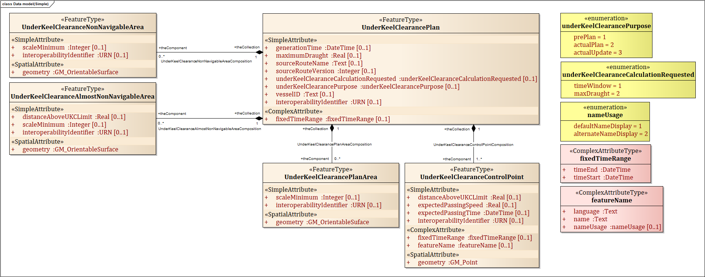
Figure 7-2. S-129 Data Model

Feature Types

UnderKeelClearancePlan
Role | Name | Description | Mult | dataType | Remarks
Class | UnderKeelClearancePlan | A UKC plan calculated for a particular vessel, for a particular passage |  | FeatureType
SimpleAttribute | generationTime | Time the UKC plan was generated | [0..1] | DateTime
SimpleAttribute | vesselID | Vessel identifier, based on MRN. Can be either IMO or MMSI based | [0..1] | Text
SimpleAttribute | sourceRouteName | Identification of the route used as a source for the calculation | [0..1] | Text | May be provided through different methods, such as S-421, RTZ, or as generated by the UKCM Service.  If provided, for example, using S-421, the value of “S-421.Route.routeID” is used for machine-readable identification, or the value of “S-421.RouteInfo.routeInfoName” is used for human-readable identification.
SimpleAttribute | sourceRouteVersion | Identification of the route used as a source for the calculation | [0..1] | Integer | May be provided through different methods, such as S-421, RTZ, or as generated by the UKCM Service.  Can be used to supplement information provided by “sourceRouteName”, especially if “sourceRouteName” provides insufficient route information.  If provided, for example, using S-421, the value of “S-421.Route.routeEditionNo” is used.
SimpleAttribute | maximumDraught | The maximum vessel draught in metres, used as base for the calculation | [0..1] | Real
SimpleAttribute | underKeelClearancePurpose | The relevant phase of a UKC passage plan. | [0..1] | underKeelClearancePurposeType
SimpleAttribute | underKeelClearanceCalculationRequested | Indication of the aim of the UKC plan: To find the maximum safe vessel draught for transiting the UKCM region, or to find sailing windows for a nominated vessel draught. | [0..1] | underKeelClearanceCalculationRequestedType
SimpleAttribute | interoperabilityIdentifier | A common unique identifier for entities which describe a single real-world feature, and which is used to identify instances of the feature in end-user systems where the feature may be included in multiple data product types. | [0..*] | URN
ComplexAttribute | fixedTimeRange | Time period | [0..1] | fixedTimeRange

UnderKeelClearancePlanArea
Role | Name | Description | Mult | dataType | Remarks
Class | UnderKeelClearancePlanArea | The area for which an under keel clearance plan has been calculated for a particular vessel, for a particular passage. |  | FeatureType
SimpleAttribute | scaleMinimum | The minimum scale at which the feature may be used for example for ECDIS presentation. | [0..1] | Integer
SimpleAttribute | interoperabilityIdentifier | A common unique identifier for entities which describe a single real-world feature, and which is used to identify instances of the feature in end-user systems where the feature may be included in multiple data product types. | [0..*] | URN
SpatialAttribute | geometry | Geometric object comes from Geometry class in S-100 standard. | [1] | GM_OrientableSurface | Boundaries of the Under Keel Clearance Plan Area.  The extents of the boundaries are likely to be updated in Actual Update datasets, to reflect areas no longer in scope of the UKC calculation.  (Refer to Section 7.1.2).

UnderKeelClearanceNonNavigableArea
Role | Name | Description | Mult | dataType | Remarks
Class | UnderKeelClearanceNonNavigableArea | An area of under keel clearance less than the calculated safe limit |  | FeatureType | The area has a time-dependent dimension
SimpleAttribute | scaleMinimum | The minimum scale at which the feature may be used for example for ECDIS presentation. | [0..1] | Integer
SimpleAttribute | interoperabilityIdentifier | A common unique identifier for entities which describe a single real-world feature, and which is used to identify instances of the feature in end-user systems where the feature may be included in multiple data product types. | [0..*] | URN
SpatialAttribute | geometry | Geometric object come from Geometry class in S-100 standard | [1] | GM_OrientableSurface | Encompassed by UnderKeelClearancePlanArea

UnderKeelClearanceAlmostNonNavigableArea
Role | Name | Description | Mult | dataType | Remarks
Class | UnderKeelClearanceAlmostNonNavigableArea | An area of under keel clearance almost less than the calculated safe limit, as established for the waterway |  | FeatureType | The area has a time-dependent dimension
SimpleAttribute | distanceAboveUKCLimit | The distance of the lowest part of the ship's keel above the established Under Keel Clearance Limit for the waterway, expressed in metres. | [0..1] | Real
SimpleAttribute | scaleMinimum | The minimum scale at which the feature may be used for example for ECDIS presentation. | [0..1] | Integer
SimpleAttribute | interoperabilityIdentifier | A common unique identifier for entities which describe a single real-world feature, and which is used to identify instances of the feature in end-user systems where the feature may be included in multiple data product types. | [0..*] | URN
SpatialAttribute | geometry | Geometric object come from Geometry class in S-100 standard | [1] | GM_OrientableSurface | Encompassed by UnderKeelClearancePlanArea

UnderKeelClearanceControlPoint
Role | Name | Description | Mult | Data Type | Remarks
Class | UnderKeelClearance  ControlPoint | Especially selected critical passage point or line |  | FeatureType
SimpleAttribute | distanceAboveUKCLimit | The distance of the lowest part of the ship's keel above the established Under Keel Clearance Limit for the waterway, expressed in metres. | [0..1] | Real
ComplexAttribute | featureName | Provides the name of an entity, defines the national language of the name, and provides the option to display the name at various system display settings. | [0..1] | featureName
SimpleAttribute | expectedPassingSpeed | The expected passing speed for a ship for a nominated Under Keel Clearance Control Point. | [0..1] | Real
SimpleAttribute | expectedPassingTime | The expected passing time for a ship for a nominated Under Keel Clearance Control Point. | [0..1] | DateTime
SimpleAttribute | interoperabilityIdentifier | A common unique identifier for entities which describe a single real-world feature, and which is used to identify instances of the feature in end-user systems where the feature may be included in multiple data product types. | [0..*] | URN
ComplexAttribute | fixedTimeRange | Time interval. | [0..1] | fixedTimeRange

Page intentionally left blank

Feature Relationship
 | Source | Mult | Target | Mult | Roles
Composition | UnderKeelClearancePlanArea | [1] | UnderKeelClearancePlan | [0..*] | Source role – theComponent  Target role – theCollection
Composition | UnderKeelClearanceNonNavigableArea | [1] | UnderKeelClearancePlan | [0..*] | Source role – theComponent  Target role – theCollection
Composition | UnderKeelClearanceAlmostNonNavigableArea | [1] | UnderKeelClearancePlan | [0..*] | Source role – theComponent  Target role –theCollection
Composition | UnderKeelClearanceControlPoint | [1] | UnderKeelClearancePlan | [1..*] | Source role – theComponent  Target role –theCollection

Complex Attribute

Fixed Time Range
Role | Name | Description | Multiplicity | Data Type | Remarks
ComplexAttribute | fixedTimeRange | Time interval.
Attribute | timeStart | The start time of an active period. | [0..1] | DateTime
Attribute | timeEnd | The end time of an active period. | [0..1] | DateTime

Feature Name
Role | Name | Description | Multiplicity | Data Type | Remarks
ComplexAttribute | featureName | Provides the name of an entity, defines the national language of the name, and provides the option to display the name at various system display settings.
Attribute | language | The method of human communication, either spoken or written, consisting of the use of words in a structured and conventional way. | [1] | Text
Attribute | name | The individual name of a feature. | [1] | Text
Attribute | nameUsage | Classification of the type and display level of the name of a feature in an end-user system. | [0..1] | Enumeration

Enumerations
Name | Description | Multiplicity | Data Type | Values
underKeelClearancePurpose | The relevant phase of a UKC passage plan. | [0..1] | Enumeration | 1: Pre Plan  2: Actual Plan  3: Actual Update
underKeelClearanceCalculationRequested | Indication of the aim of the UKC plan: To find the maximum safe vessel draught for transiting the UKCM region, or to find sailing windows for a nominated vessel draught. | [0..1] | Enumeration | 1: Time Window  2: Maximum Draught
nameUsage | Classification of the type and display level of the name of a feature in an end-user system. | [0..1] | Enumeration | 1: defaultNameDisplay  2: alternateNameDisplay

Feature Catalogue

Introduction
As outlined in ISO 19110, catalogues contain definitions and descriptions of the spatial object types, their attributes and associated components occurring in one or more spatial datasets, together with any operations that may be applied.
A Feature Catalogue (FC) refers to a description of an abstraction of reality that may be used to depict one or more geographic datasets. The FC for S-129 uses GML to describe the details of the application schema contained in Section 7.2 and is verified by the IHO’s Feature Catalogue Builder (FCB).
The FC describes the features, information types, attributes, attribute values, associations and roles which may be in a UKCM dataset. The S-129 FC is described in XML which conforms to the S-100 XML Feature Catalogue Schema.

Feature Catalogue and can be downloaded from the IHO GI Registry website (https://registry.iho.int/productspec/list.do).

Feature Types
Feature types contain descriptive attributes that characterize real-world entities. The word ‘feature’ may be used in one of two senses – feature type and feature instance. A feature type is a class and is defined in a Feature Catalogue. A feature instance is a single occurrence of the feature type and represented as an object in a dataset. A feature instance is located by a relationship to one or more spatial instances. In this specification, a feature instance may not exist without referencing a spatial instance.

Geographic
A Geographic (Geo) feature type carries the descriptive characteristics of a real-world entity. A Geo feature type forms the principal content of the dataset and is fully defined by its associated attributes and information types.

Meta
Meta features contain information about other features within a dataset. Information defined by meta features override the default metadata values defined by the dataset descriptive records. Meta attribution on individual features overrides attribution on meta features.
Meta features must be used to their maximum extent to reduce meta attribution on individual features.

Feature Relationship
A feature relationship links instances of one feature type with instances of the same or a different feature type. Although there are four types of defined feature relationships in S-100, S-129 uses only one of these – composition.

Aggregation
An aggregation is a relationship between two or more feature types where the aggregation feature is made up of component features.

Composition
A composition is a strong aggregation. In a composition, if a container feature is deleted then all its component features are deleted as well.
EXAMPLE: A UKC plan feature may comprise multiple UKC non-navigable area features to indicate unsafe areas, computed based on information as contained in the UKC plan feature. Therefore, if a UKC plan feature is deleted, its component UKC non-navigable area features must also be deleted as they make up the UKC non-navigable area/UKC plan Composition.

Attributes
S-100 defines attributes as either simple or complex.

Simple attributes
S-129 uses five types of simple attributes, as listed in Table 8-1.
Type | Definition
Enumeration | A fixed list of valid identifiers of named literal values.
Real | A signed Real (floating point) number consisting of a mantissa and an exponent.
Integer | A signed integer number. The representation of an integer is encapsulation and usage dependent.
Character String | An arbitrary-length sequence of characters including accents and special characters from a repertoire of one of the adopted character sets.
Date and Time | A DateTime is a combination of a date and a time type. Character encoding of a DateTime must follow ISO 8601-1:2019 and ISO 8601-2:2019.
Table 8-1 – Attribute types

Complex attributes
Complex attributes are aggregations of other attributes that are either simple or complex. The aggregation is defined by means of attribute bindings. S-129 includes the following complex attributes:
- fixedTimeRange – contains simple attributes of “timeStart” and “timeEnd”
- featureName – contains simple attributes of “name”, “language”, and “nameUsage”
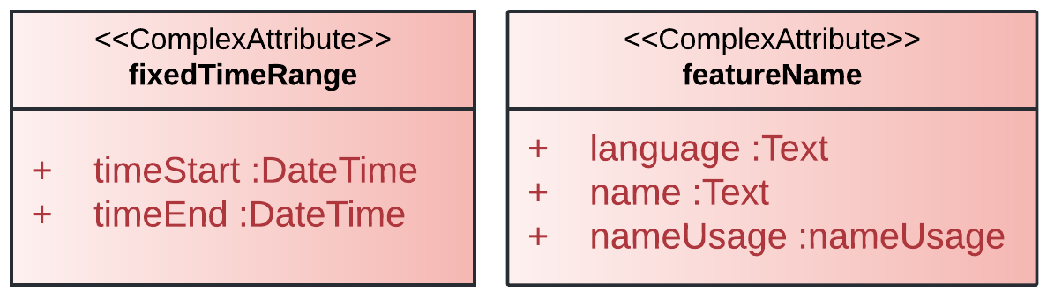
Figure 8-1 –Complex Attributes used in S-129

Units of measure
The following units of measure are used in the S-129 Product Specification:
- Ship draught in metres
- Ship speed in metres per second
- UKC above the established UKC Limit, in metres

Dataset Types
UKCM datasets consists of a UKC plan, UKC plan area, control points and areas considered non-navigable and almost non-navigable. The datasets are generally intended for use with S-101 ENC, and (optionally) with S-102 (Bathymetric Surface), S-104 (Water Level Information for Surface Navigation), or S-111 (Surface Currents) datasets. Dataset content will change over time during a ship’s transit. Updating of datasets is achieved by replacement.

Dataset Loading and Unloading
S-129 datasets are typically intended to be overlays to S-101 ENC and always displayed with S-101 ENC data in the background. Systems that support the display of S-129 datasets should provide the user with simple functions to turn the display of S-129 datasets on and off.
All S-129 datasets are scale independent and will therefore be usable across the entire scale range of underlying chart data for the UKCM Operational Area. The various feature instances within the dataset may include scaleMinimum attributes, but these do not change the resolution or validity of the data, only whether the data should be visible at a particular display scale.
Optionally, S-129 datasets can be viewed as overlays to a combination of S-101 ENC and S-102 (Bathymetric Surface) datasets, with S-104 (Water Level Information for Surface Navigation) datasets incorporated where applicable. The same requirements to allow the user to easily toggle the S-129 dataset on/off persist.

Geometry
Geometry in S-129 datasets conforms to S-100 Geometry level 3a constrained to 2-dimensional geometry.

Coordinate Reference Systems (CRS)

Introduction
The location of a feature in the S-100 standard is defined by means of coordinates, which relate a feature to a position.
Horizontal coordinate reference system: EPSG:4326 (WGS84)
Projection: None
Temporal reference system: Gregorian calendar
Coordinate reference system registry: EPSG Geodetic Parameter Registry
Date type (according to ISO 19115): 002 – publication
Responsible party: International Association of Oil and Gas Producers (IOGP)
URL: http://www.iogp.org
NOTE: To match WGS84 specification, coordinate order in S-129 GML files must be latitude followed by longitude.

Horizontal Reference System
In S-129 datasets the horizontal CRS must be the ellipsoidal (geodetic) system EPSG: 4326 (WGS84). The full reference to EPSG: 4326 can be found at https://epsg.org/

Vertical Reference System
The vertical coordinate is directed upward from its origin (that is, away from the Earth’s centre) – the vertical datum – and has units of metres. That is, a positive value for the level relative to the vertical datum means that the level is above the vertical datum. This is consistent with the bathymetric CRS in S-102 Edition 1.0.0. The vertical datum is not an ellipsoid but is one of the following: (a) the sea surface (defined in clause 3.2), (b) a vertical, sounding, or chart datum (MSL, LAT, etc.), or (c) the sea floor.

Temporal Reference System
The temporal reference system is the Gregorian calendar for date and UTC for time. Time is measured by reference to Calendar dates and Clock time in accordance with ISO 19108:2002, Temporal Schema clause 5.4.4. All date and time variables must follow the format specified in ISO 8601-1:2019 and ISO 8601-2:2019.
- A date variable will have the following 8-character format: yyyymmdd.
- A time variable will have the following 7-character format: hhmmssZ.
- A date-time variable will have the following 16-character format: yyyymmddThhmmssZ.

Data Quality

Introduction
Data quality allows users and user systems to assess fitness for use of the provided data. Data quality measures and the associated evaluation are reported as metadata of a data product. This metadata improves interoperability with other data products and provides scope for usage by user groups that the data product was not originally intended for. The secondary users can make assessments of the data product usefulness in their application based on the reported data quality measures.
For S-129 the following Data Quality Elements have been included:
- Conformance to this Product Specification;
- Intended purpose of the data product;
- Completeness of the data product in terms of coverage;
- Logical consistency;
- Positional uncertainty and accuracy;
- Thematic accuracy;
- Temporal quality;
- Aggregation measures;
- Validation checks or conformance checks including:
  - General tests for dataset integrity;
  - Specific tests for a specific data model.

Data Quality Indication Within S-129 Datasets
Areas where UKCM Services are in place are typically covered by very high-definition bathymetry, and have available predicted and observed (that is, real time or near real time) met-ocean data. Quality of UKCM products used for navigation depends on the combined quality of such data, as well as the quality of ship characteristics and positional data. Quality information relevant to the many data inputs used by a UKCM Service is difficult to produce as a meaningful metric of UKCM product quality able to be understood by the mariner.
Bathymetric, tidal and other met-ocean data used to generate products in compliance with this Product Specification are provided by official sources using quality assured processes outside the scope of this Product Specification. This information is, therefore, assumed to be of high quality and guaranteed by the processes employed by the relevant authorities.
UKCM services also generate

UKCM information containing margins that account for uncertainty to guarantee the safety of individual ships for stated periods of validity.

Completeness
The presence and absence of features is described by the data quality elements Completeness (including commission and omission). Completeness should only be used on the feature type level, describing whether the features in the universe of discourse are found in the data set or not.

Commission
Commission is applicable for S-129.
S-129 products must be tested with commission checks prior to release by the Data Producer. The Data Producer must review the check results and address any issues to ensure sufficient quality of the data products. The checks listed in IHO Publications S-158:100 – S-100 Validation Checks and S-158:129 – S-129 Validation Checks include data validation check(s) intended to identify excess and/or duplicate items.
Data should only be published if it passes the test.
S-129 quality testing must populate numberOfExcessItems with the number of items that should not have been present in the dataset and numberOfDuplicateFeatureInstances with the total number of exact duplications of feature instances within the data.

Omission
Omission is applicable for S-129.
S-129 products must be tested with omission checks prior to release by the Data Producer. The Data Producer must review the check results and address any issues to ensure sufficient quality of the data products. The checks are listed in IHO Publications S-158:100 – S-100 Validation Checks and S-158:129 – S-129 Validation Checks.
Data should only be published if it passes the test.
S-129 products must populate numberOfMissingItems that indicates the total number of missing items.

Logical Consistency

Conceptual Consistency
Conceptual Consistency is applicable for S-129.
S-129 products must be tested with conceptual consistency checks prior to release by the Data Producer. The Data Producer must review the check results and address any issues to ensure sufficient quality of the data products. The checks are listed in IHO Publications S-158:100 – S-100 Validation Checks and S-158:129 – S-129 Validation Checks.
Data should only be published if it passes the test.
In terms of conceptual consistency, S-129 products shall at least populate numberOfNonCompliantItems that is a count of all items in the dataset that are noncompliant to the rules of the Conceptual Schema. As a Product Specification with geometric surfaces, S-129 shall also at least populate numberOfInvalidSurfaceOverlaps that indicates the total number of erroneous overlaps within the data.

Domain Consistency
Domain consistency is applicable for S-129.
S-129 products must be tested with domain consistency checks prior to release by the Data Producer. The Data Producer must review the check results and address any issues to ensure sufficient quality of the data products. The checks are listed in IHO Publications S-158:100 – S-100 Validation Checks and S-158:129 – S-129 Validation Checks.
Data should only be published if it passes the test.
The Product Specification must describe how domain consistency is to be populated; for example, stating the mechanism to reference the quality evaluation procedure, and allowable values for the quality results.
In terms of domain consistency, S-129 products must at least populate numberOfNonconformantItems that is a count of all items in the dataset that are not in conformance with their value domain.

Format Consistency
Format Consistency is applicable for S-129.
S-129 products must be tested with format consistency checks prior to release by the Data Producer. The Data Producer must review the check results and address any issues to ensure sufficient quality of the data products. The checks are listed in IHO Publications S-158:100 – S-100 Validation Checks and S-158:129 – S-129 Validation Checks.
Data should only be published if it passes the test.
S-129 products must at least populate physicalStructureConflictsNumber that is a count of all items in the dataset that are stored in conflict with the physical structure of the dataset.

Topological Consistency
Topological Consistency is applicable for S-129 and follows the guidelines from S-100, Part 7.

Positional Accuracy

Absolute or External Accuracy

Vertical Position Accuracy
Vertical Position Accuracy is not applicable for S-1XX which is a Product Specification without objects that have a vertical coordinative value associated.
[Or Option2:]
Vertical position accuracy is applicable for S-129.
S-1XX S-129 products must be tested with vertical position accuracy checks prior to release by the Data Producer. The Data Producer must review the check results and address any issues to ensure sufficient quality of the data products. The checks are listed in <X>. [Option 2a.1:] Data should only be published if it passes the test. [Or Option 2a.2:] It is allowable to publish the data with a quality statement which indicates non-conformance.
[Option 2b.1:] The Product Specification must describe how vertical position accuracy is to be populated; for example, stating the mechanism to reference the quality evaluation procedure, and allowable values for the quality results.
[Or Option 2b.2:] In terms of vertical position accuracy, S-1XX products must at least populate linearMapAccuracy3Sigma that indicates the attribute value of uncertainty where half the length of the interval defined by an upper and lower limit in which the true value lies with a probability of 90%.

Horizontal Position Accuracy

Relative or Internal Accuracy

Gridded Data Positional Accuracy
Gridded data positional accuracy is not applicable for S-129 which is a Product Specification without objects that have a gridded coordinative value associated.

Thematic Accuracy

Temporal Quality

Temporal Consistency
Temporal Consistency is not applicable for S-129 which is a Product Specification without ordered events or sequences.

Temporal Validity
Temporal validity is applicable for S-129.
S-129 products must be tested with temporal validity checks prior to release by the Data Producer. The Data Producer must review the check results and address any issues to ensure sufficient quality of the data products. The checks are listed in IHO Publications S-158:100 – S-100 Validation Checks and S-158:129 – S-129 Validation Checks.
Data should only be published if it passes the test.
In terms of temporal validity, S-129 products must at least populate numberOfNonConformantItems that is a count of all items in the dataset that are not in conformance with their value domain.

Temporal Accuracy
Temporal accuracy is applicable for S-129.
S-129 products must be tested with temporal accuracy checks prior to release by the Data Producer. The Data Producer must review the check results and address any issues to ensure sufficient quality of the data products. The checks are listed in IHO Publications S-158:100 – S-100 Validation Checks and S-158:129 – S-129 Validation Checks.
Data should only be published if it passes the test.
The Product Specification must describe how temporal accuracy is to be populated; for example, stating the mechanism to reference the quality evaluation procedure, and allowable values for the quality results.

Aggregation

Applicable Quality Measures
Table 13-1 – List of data quality measures in S-129
No. | Data Quality Measure | Definition | DQ measure / description | Evaluation scope | Scope in S-129
1 | Completeness / Commission | Excess data present in a dataset, as described by the scope. | numberOfExcessItems / This data quality measure indicates the number of items in the dataset, that should not have been present in the dataset. | dataset/dataset series | whole dataset
2 | Completeness / Commission | Excess data present in a dataset, as described by the scope. | numberOfDuplicateFeatureInstances / This data quality measure indicates the total number of exact duplications of feature instances within the data. | dataset/dataset series | whole dataset
3 | Completeness / Omission | Data absent from the dataset, as described by the scope. | numberOfMissingItems / This data quality measure is an indicator that shows that a specific item is missing in the data. | dataset/dataset series/spatial object type | whole dataset,  features
4 | Logical Consistency / Conceptual Consistency | Adherence to the rules of a conceptual schema. | numberOfNonCompliantItems / This data quality measure is a count of all items in the dataset that are noncompliant to the rules of the Conceptual Schema. | spatial object / spatial object type | features
5 | Logical Consistency / Conceptual Consistency | Adherence to the rules of a conceptual schema | numberOfInvalidSurfaceOverlaps / This data quality measure is a count of the total number of erroneous overlaps within the data. Which surfaces may overlap and which must not is application dependent. Not all overlapping surfaces are necessarily erroneous. | spatial object / spatial object type | features with surface geometry
6 | Logical Consistency / Domain Consistency | Adherence of the values to the value domains. | numberOfNonconformantItems / This data quality measure is a count of all items in the dataset that are not in conformance with their value domain. | spatial object / spatial object type | features
7 | Logical Consistency / Format Consistency | Degree to which data is stored in accordance with the physical structure of the data set, as described by the scope | physicalStructureConflictsNumber / This data quality measure is a count of all items in the dataset that are stored in conflict with the physical structure of the dataset. | dataset/dataset series | whole dataset
8 | Logical Consistency / Topological Consistency | Correctness of the explicitly encoded topological characteristics of the dataset, as described by the scope. | rateOfFaultyPointCurveConnections / This data quality measure indicates the number of faulty link-node connections in relation to the number of supposed link-node connections. This data quality measure gives the erroneous point-curve connections in relation to the total number of point-curve connections. | spatial object / spatial object type | NA
9 | Logical Consistency / Topological Consistency | Correctness of the explicitly encoded topological characteristics of the dataset, as described by the scope. | numberOfMissingConnectionsUndershoots / This data quality measure is a count of items in the dataset within the parameter tolerance that are mismatched due to undershoots. | spatial object / spatial object type | NA
10 | Logical Consistency / Topological Consistency | Correctness of the explicitly encoded topological characteristics of the dataset, as described by the scope. | numberOfMissingConnectionsOvershoots / This data quality measure is a count of items in the dataset within the parameter tolerance that are mismatched due to overshoots. | spatial object / spatial object type | NA
11 | Logical Consistency / Topological Consistency | Correctness of the explicitly encoded topological characteristics of the dataset, as described by the scope. | numberOfInvalidSlivers / This data quality measure is a count of all items in the dataset that are invalid sliver surfaces. A sliver is an unintended area that occurs when adjacent surfaces are not digitized properly. The borders of the adjacent surfaces may unintentionally gap or overlap to cause a topological error. | dataset / dataset series | features with surface geometry
12 | Logical Consistency / Topological Consistency | Correctness of the explicitly encoded topological characteristics of the dataset, as described by the scope. | numberOfInvalidSelfIntersects / This data quality measure is a count of all items in the dataset that illegally intersect with themselves. | spatial object / spatial object type | features with surface geometry
13 | Logical Consistency / Topological Consistency | Correctness of the explicitly encoded topological characteristics of the dataset, as described by the scope. | numberOfInvalidSelfOverlap / This data quality measure is a count of all items in the dataset that illegally self-overlap. | spatial object / spatial object type | features with surface geometry
14 | Positional Accuracy / Vertical Position Accuracy | Closeness of reported coordinative values to values accepted as or being true. | LinearMapAccuracy3Sigma / Half length of the interval defined by an upper and lower limit in which the true value lies with probability 95%. | spatial object / spatial object type
15 | Positional Accuracy / Horizontal Position Accuracy | Closeness of reported coordinative values to values accepted as or being true. | circularError95/Radius describing a circle in which the true point location lies with the probability of 95%. | spatial object / spatial object type
16 | Positional Accuracy / Relative or Internal Accuracy | Closeness of the relative positions of features in a dataset to their respective relative positions accepted as or being true. | relativeVerticalError / An evaluation of the random errors of one relief feature to another in the same data set or on the same map / chart. It is a function of the random errors in the two elevations with respect to a common vertical datum. [Adapted from ISO 19157] | spatial object / spatial object type
17 | Positional Accuracy / Relative or Internal Accuracy | Closeness of the relative positions of features in a dataset to their respective relative positions accepted as or being true. | relativeHorizontalError / An evaluation of the random errors in the horizontal position of one feature to another in the same data set or on the same map/chart. [Adapted from ISO 19157] | spatial object / spatial object type
18 | Positional Accuracy / Gridded Data Position Accuracy | Closeness of reported coordinative values to values accepted as or being true. | RMSErrorPlanimetry / Radius of a circle around the given point, in which the true value lies with probability P. | spatial object / spatial object type | NA
19 | Temporal Quality / Temporal Consistency | Correctness of ordered events or sequences, if reported. | chronologicalOrder / This data quality measure that indicate that an event is incorrectly ordered against the other events. [Adapted from ISO 19157] | dataset/dataset series/spatial object type | NA
20 | Temporal Quality / Temporal Validity | Validity of data with respect to time | numberOfNonConformantItems / This data quality measure is a count of all items in the dataset that are not in conformance with their value domain. [Adapted from ISO 19157] | dataset/dataset series/spatial object type | feature types UnderKeelClearancePlan and UnderKeelClearanceControlPoint
21 | Temporal Quality / DQ_AccuracyOfATimeMeasurement | Correctness of the temporal references of an item (reporting of error in time measurement) | attributeValueUncertainty3Sigma / This data quality measure indicates the attribute value of uncertainty where half the length of the interval defined by an upper and lower limit in which the true value for the quantitative attribute lies with a probability of 95%. [Adapted from ISO 19157] | dataset/dataset series/spatial object type | feature types UnderKeelClearancePlan and UnderKeelClearanceControlPoint
22 | Thematic Accuracy / ThematicClassificationCorrectness | Comparison of the classes assigned to features or their attributes to a universe of discourse. | miscalculationRate / This data quality measure indicates the number of incorrectly classified features in relation to the number of features that are supposed to be there. [Adapted from ISO 19157]  This is a RATE which is a ratio, and is expressed as a REAL number representing the rational fraction corresponding to the numerator and denominator of the ratio.  For example, if there are 1 items that are classified incorrectly and there are 100 of the items in the dataset then the ratio is 1/100 and the reported rate = 0.01. | dataset/dataset series/spatial object type
23 | Thematic Accuracy / Non-Quantitative Attribute Accuracy | Correctness of non-quantitative attribute. | numberOfIncorrectAttributeValues / This data quality measure is count of the total number of erroneous attribute values within the relevant part of the dataset. It is a count of all attribute values where the value is incorrect. [Adapted from ISO 19157] | dataset/dataset series/spatial object type
24 | Thematic Accuracy / Quantitative Attribute Accuracy | Accuracy of a quantitative attribute. | attributeValueUncertainty3Sigma / This data quality measure indicates the attribute value of uncertainty where half the length of the interval defined by an upper and lower limit in which the true value for the quantitative attribute lies with a probability of 95%. [Adapted from ISO 19157] | dataset/dataset series/spatial object type
25 | Aggregation Measures / AggregationMeasures | In a data Product Specification, several requirements are set up for a product to conform to the Specification. | DataProductSpecificationPassed / This data quality measure is a boolean indicating that all requirements in the referred data Product Specification are fulfilled. | dataset/dataset series/spatial object type
26 | Aggregation Measures / AggregationMeasures | In a data Product Specification, several requirements are set up for a product to conform to the specification. | DataProductSpecificationFailRate / This data quality measure is a number indicating the number of data Product Specification requirements that are not fulfilled by the current product/dataset in relation to the total number of data Product Specification requirements. | dataset/dataset series/spatial object type

Data Capture and Classification
The S-129 Data Classification and Encoding Guide (DCEG) gives guidance for how to encode UKCM datasets for the various stages of a journey to and through a UKCM Operational Area. The document can be found in Annex A.

Maintenance
Dataset maintenance is dependent on local conditions and the policies of the UKCM Service Provider. Typically, a ship would be sent several UKCM information products during a transit of a UKCM Operational Area in order to ensure the ship has correct and up-to-date UKCM information.

Maintenance and Update Frequency
In the pre-planning use case the UKCM Service may simply compute a tidal window based on predicted tide, forecast navigable depths (including safety/manoeuvrability margins) ship maximum draught, speed and squat predictions, other forecast environmental conditions and standard assumed route. In this pre-planning scenario, the UKCM Service could only return a single dataset and generally no updates would be required until closer to the time of the ship entering the UKCM Operational Area (for example, 24 hours prior).
Closer to the time of the ship entering the UKCM Operational Area, the ship will need a more detailed passage plan, which will be updated more frequently. Depending on the variability of the observed and forecast conditions in the UKCM Operational Area, the update frequency might range between 10 minutes to 60 minutes.
As the ship is approaching the UKCM Operational Area, more up-to-date information will be required and UKCM product datasets may be updated as frequently as, for example, every five to ten minutes.

Data Source
Data sources used when creating UKCM product datasets can vary with each UKCM Operational Area. Source information can include high-definition bathymetric data, observed or forecast water level, current, tidal stream, and observed or forecast climatic data. This information is combined into a model that contains ship details such as draughts, speed and position to create UKCM product datasets that are individually tailored for each ship.

Production Process
The production process of UKCM product datasets will vary depending on the environmental sensors used in each UKCM Operational Area and may also vary depending on the stage of a ship’s passage.

Portrayal
The Portrayal Catalogue (PC) in Annex D defines how S-129 datasets are to be portrayed. The PC specifies the symbols and portrayal rules needed to display S-129 features.
The PC contains portrayal functions to map the features to symbols, symbol definitions, line styles, colour definitions, portrayal parameters and portrayal management concepts such as viewing groups.

Data Product Format (Encoding)
The GML encoding of S-129 datasets is based on the S-100 profile of GML 3.2.1. This is described in S-100 Edition 5.2.1 Part 10b.
Detailed documentation of the S-129 encoding schema is provided in Annex B of this document.
Format Name: GML
Version: 3.2.1
Character Set: UTF-8
Specification: S-100 5.2.1 profile of GML 3.2.1

Encoding of Latitude and Longitude
Values of latitude and longitude must be expressed with a precision of 7 decimal places. Coordinates must be encoded as decimals in the format described below. The encoding is indicated by multiplication factor fields defined in the S-100 GML schema dataset identification record.

Encoding of coordinates as decimals
Values should be coded as decimal numbers with 7 or fewer digits after the decimal. The normative encoding is in degrees, with an accuracy of 10⁻⁷ degrees (that is, 7 digits after the decimal point). The decimal point must be indicated by the “.” character.
Trailing zeroes after the decimal point (and the decimal point itself if appropriate) may be omitted at producer discretion, but the accuracy must still be as indicated (for example 10⁻⁷ degrees for coordinates of default accuracy).

Numeric Attribute Encoding
Floating point and integer attribute values must not contain leading zeros. Floating point attribute values must not contain non-significant trailing zeros.

Text Attribute Values
Character strings must be encoded using the character set defined in ISO 10646-1, in Unicode Transformation Format-8 (UTF-8).

Mandatory Attribute Values
There are four reasons why attribute values may be considered mandatory:
- They determine whether a feature is in the display base.
- Certain features make no logical sense without specific attributes.
- Some attributes are necessary to determine which symbol is to be displayed.
- Some attributes are required for safety of navigation.
All mandatory attributes are identified in the Feature Catalogue and summarised in Annex A – Data Classification and Encoding Guide.

Unknown Attribute Values
When a mandatory attribute code or tag is present, but the attribute value is missing, it means that the producer wishes to indicate that this attribute value is unknown. Missing mandatory attributes must be “nilled” with a GML nilReason attribute giving the reason for omission.
Optional attributes must be omitted altogether if the value is unknown or missing. They must not be “nilled.”

Structure of dataset files

Sequence of objects
The order of data objects in each dataset file is described below:
- Dataset identification information
- Dataset structure information
- Spatial records for by-reference geometries
  - Point
  - Multi point
  - Curve
  - Composite curve
  - Surface
- Information objects
- Feature objects (Geometry may be encoded inline or by reference)
  - Meta features
  - Geo features
- S-129 Collection objects

Object identifiers
The name of feature records must provide a unique world-wide identifier of feature records. The name of the record is the combination of the sub-fields agency, featureObjectIdentifier and featureIdentificationSubdivision elements of the featureObjectIdentifier element of the object.
Features, information types, collection objects, meta features, and geometries (inline or external) are all required by the schema to have a gml:id attribute with a value that is unique within the dataset. The gml:id values must be used as the reference for the object from another object in the same dataset or another dataset.

Dataset validation
Fields may be repeated or omitted as permitted by the XML schemas and the validation tests. Since XML schema cannot encode rules for conditional presence or attributes, these rules can be checked by Schematron rules or other validation code.

Data overlap
S-129 datasets may spatially overlap other S-129 datasets.
S-129 datasets may temporally overlap other S-129 datasets. As S-129 datasets include forecast information, it is possible that S-129 datasets for different vessels correspond to overlapping voyage times or sailing windows.
In the case of S-129 dataset updates, new S-129 datasets can replace preceding S-129 datasets for the same vessel, UKCM Operational Area, and planned time of voyage, to account for prevailing environmental and/or voyage conditions.

Data Product Delivery

Introduction
This clause specifies the encoding and delivery mechanisms for an S-129 dataset. Data which conforms to this Product Specification must be delivered by means of an exchange set.
Units of Delivery: Exchange set
Transfer Size: See Clause 18.2.2
Medium Name: Digital data delivery
Other Delivery Information:
Each dataset must be contained in a separate, uniquely identified file on the transfer medium.
Each exchange set has a single exchange catalogue, which contains the discovery metadata for each dataset and references to any support files.
Support files contain supplementary information which is linked to the features and information types by attributes. The attributes containing these links are described in the Application Schema and Feature Catalogue.
An exchange set may be encapsulated in a form suitable for transmission by a mapping called a transmission encoding. An encoding translates each of the elements of the exchange set into a logical form suitable for writing to media and for transmission. An encoding may also define other elements in addition to the exchange set contents (for example media identification, data extents, etc.) and also may define commercial constructs such as encryption and compression methods.
Depending on the required level of detail, particularly when non-navigable and almost non-navigable areas are included, S-129 files can be constructed accordingly to maximise efficiency of transmission.
Further, S-129 files can be compressed using guidance provided in S-100 Part 15 in cases where files would otherwise take too long to transmit.
It is anticipated that uncompressed S-129 files for an area of 36 by 10 nautical miles, may range in size between 0.65MiB and 2.4MiB, depending on the complexity and extent of the no-go areas. Compressed versions of such files can reduce file sizes to between 27KiB and 91KiB respectively.
If the data is transformed (for example for encryption or compression purposes) its content must not be changed.
This Product Specification defines the transmission encoding which must be used as a default for transmission of data.
The exchange set elements are as follows:
Mandatory Elements:
- S-129 datasets – GML encoding of features/attributes and their associated geometry and metadata.
- Exchange Catalogue – the XML encoded representation of exchange set catalogue features [discovery metadata].
Optional Elements:
- Supplementary files – These are contained within the exchange set as files and the map from the name included within the dataset and the physical location is defined within the Exchange Catalogue.
- Feature Catalogue – If it is necessary to deliver the latest Feature Catalogue to the end user it may be done using the S-129 exchange set mechanism for datasets (that is, include the updated Feature Catalogue in an exchange set).
- Portrayal Catalogue – If it is necessary to deliver the latest Portrayal Catalogue to the end user it may be done using the S-129 exchange set mechanism for datasets (that is, include the updated Portrayal Catalogue in an exchange set).
S-129 Exchange set structure conforms to S-100 Part 4a, Figure 4a-D-3 without modification.

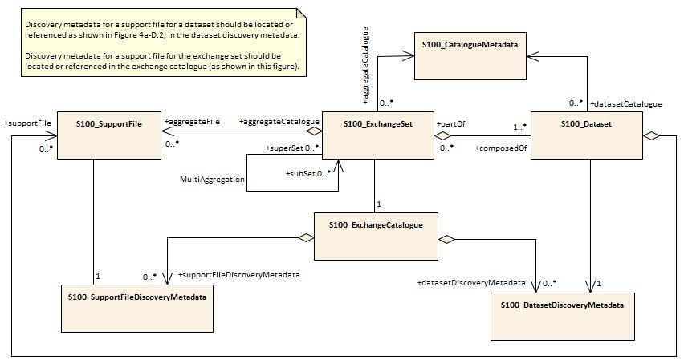
Figure 18-1 – Exchange set structure

Catalogue File Naming Convention
The exchange catalogue acts as the table of contents for the exchange set. The catalogue file of the exchange set must be named CATALOG.XML. No other file in the exchange set may be named CATALOG.XML. The content of the exchange catalogue file is described in clause 19.5.

Dataset

Datasets
Datasets are distributed as files which are part of exchange sets structured as described in this Product Specification. The distribution media or transmission method is at the discretion of the producer and/or distributor.
The encoding structure is included in Annex B.

New Datasets and New Editions
Datasets can be classified as a new dataset, or a new edition of a dataset, as described in S-100 Part 17, Clause 17-4.4.1:

- New dataset (base dataset) – initially created
New S-129 datasets correspond to the first UKC passage plan calculation for a vessel.
Dataset discovery metadata must be encoded as follows:
- editionNumber must be 1 (Clause 19.6)
- updateNumber must be 0 (Clause 19.6)
- purpose must be newDataset (Clause 19.6, Clause 19.6.3)

- New edition of a dataset
New edition of an S-129 dataset may correspond to a recalculated UKC passage plan based on prevailing conditions, and/or changes in the phase of the plan (i.e. underKeelClearancePurpose).
Dataset discovery metadata must be encoded as follows:
- editionNumber incremented by 1 with each edition (Clause 19.6)
- updateNumber must be 0 (Clause 19.6)
- purpose must be newEdition (Clause 19.6, Clause 19.6.3)
- issueDate and issueTime must reflect a later timestamp than that of the dataset being replaced
Each new edition of a dataset must have the same name as the dataset that it replaces. A new edition can also contain data that has previously been produced for the same UKCM Operational Area.

Updating Datasets
S-129 does not support delta changes to issued S-129 datasets. Updates to a given UKC passage plan are achieved by issuing new editions of the datasets.

Dataset Cancellation
S-129 datasets can be cancelled in any one the following ways:

- Its temporal extent (i.e. temporalExtent metadata; Clause 19.6) is exceeded
- Fileless cancellation has been issued.
Fileless cancellation is achieved by using a dataset discovery metadata entries with the file name and original producer’s digital signature specifying the resource to be cancelled. All mandatory metadata fields must be set to the same values as the original, with the exception of:
  - issueDate set to the issue date of the fileless cancellation itself (Clause 19.6)
  - purpose must be cancellation (Clause 19.6, Clause 19.6.3)
  - replacedData set to either True or False (Clause 19.6)
    - if replacedData set to True, dataReplacement must be populated with at least on replacement dataset name
  - signatureOnSignature must be populated (S-100 Part 15, Clause 15-8.11.5)
    - signatureRef attribute must reference the original producer’s signatureOnData id
- File based cancellation has been issued.
File based cancellation is achieved by issuing of a cancellation dataset, with all mandatory dataset discovery metadata fields set to the same values as the original, with the exception of:
  - issueDate set to the issue date of the fileless cancellation itself (Clause 19.6)
  - purpose must be cancellation (Clause 19.6, Clause 19.6.3)
  - replacedData set to either True or False (Clause 19.6)
    - if replacedData set to True, dataReplacement must be populated with at least on replacement dataset name
  - editionNumber must be set to the current editionNumber of the dataset being cancelled

Dataset size
The recommended maximum file size for S-129 UKCM datasets is 19MiB. Future usage or testing may result in a different recommended file size limit.

Dataset file naming
Dataset files shall be named:
129XXXX[<identifier>].GML
The file name forms a unique identifier where:
- 129 – the first three characters are fixed to 129, and identify the dataset as a S-129 dataset.
- XXXX – the fourth to seventh characters indicate Producer Code of the issuing agency (mandatory). Producer Codes may be obtained from the Producer Code Register in the IHO GI Registry. The four-character S-100 “Alpha” codes must be used.
- <identifier> – the eighth to the maximum fifty-third characters are optional and may be used in any way by the producer to provide the unique file name. It is not required to use all characters. The following characters are allowed in the dataset name:
  - Alphanumeric characters A-Z, a-z, 0-9
  - The hyphen and underscore characters (“-“ and “_”)
- GML – the character sequence “GML” as file extension (must be uppercase).
- The maximum length of the of S-129 datasets is therefore 64 characters.

Support Files
An S-129 Exchange Set may include support files containing supplementary information to assist end users with passage planning and execution, and to enhance the safety of navigation.

Support File Naming
Support files shall be named:
129XXXX[<identifier>].EEE
The file name forms a unique identifier where:
- 129 – the first three characters are fixed to 129, and identify the dataset as a S-129 dataset.
- XXXX – the fourth to seventh characters indicate Producer Code of the issuing agency (mandatory). Producer Codes may be obtained from the Producer Code Register in the IHO GI Registry. The four-character S-100 “Alpha” codes must be used.
- <identifier> – the eighth to the maximum fifty-third characters are optional and may be used in any way by the producer to provide the unique file name. It is not required to use all characters. The following characters are allowed in the dataset name:
  - Alphanumeric characters A-Z, a-z, 0-9
  - The hyphen and underscore characters (“-“ and “_”)
- EEE – support file extension (must conform to the file format; refer to S100_SupportFileFormat under S-100 Part 17 Clause 17-4.5)
- The maximum length of the of S-129 datasets is therefore 64 characters.

Data Integrity
S-100 Part 15 defines the algorithms for compressing, encrypting and digitally signing datasets based on the S-100 Data Model. The individual Product Specifications provide details about which of the elements are being used and on which files in the dataset.

Data Encryption
Dataset files may or may not be encrypted. If encrypted, the encryption method defined in S-100 Part 15 must be applied.

Use of Digital Signatures
Digital signatures shall be used on all files. The signature method is defined in S-100 Part 15.

Metadata

Introduction
The S-129 UKCM metadata description is based on S-100 Part 17 Discovery Metadata for Information Exchange Catalogues, which is a profile of the ISO 19115 standard. These documents provide a structure for describing digital geographic data, and define metadata elements, a common set of metadata terminology, definitions and extension procedures. Detailed information is provided in S-100 Part 17.
Two metadata packages are described in this Product Specification: dataset metadata; and, exchange set metadata.
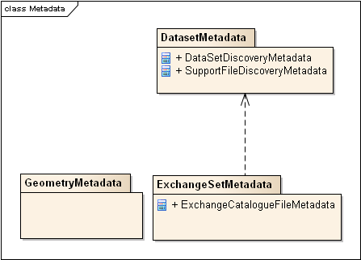
Figure 19-1 – Metadata packages
NOTE 1: Types with CI_, EX_, and MD_ prefixes are from packages defined in ISO 19115 and adapted by S-100. Types with S100_ prefix are from packages defined in S-100.
NOTE 2: When a dataset is terminated, the ‘purpose’ metadata field is set to 3 (terminated), and the ‘editionNumber’ metadata field is set to 0. All other metadata fields must be blank.
NOTE 3: The implication of only updating by new edition is that, if a support file is terminated a new edition of the dataset is required.

Use of S-421 to provide routes in UKC plans
Figure 19-2 – relationship between S-129 and S-421
To provide a UKCM Service, and a UKC route plan in particular, it is recommended that S-421, if available, be used to generate a ship’s route through the UKCM Operational Area. Figure 19-2 shows the relationship between S-129 and S-421.
If S-421 is unavailable, alternative methods, such as RTZ route plan exchange format, can be used to provide or generate a ship’s route information through the UKCM Operational Area.

Language
The language used for the metadata is English.

Dataset metadata
Dataset metadata is intended to describe information about a dataset. It facilitates the management and exploitation of data and is an important requirement for understanding the characteristics of a dataset. Whereas dataset metadata is usually fairly comprehensive, there is also a requirement for a constrained subset of metadata elements that are usually required for discovery purposes. Discovery metadata are often used for building web catalogues, and can help users determine whether a product or service is fit for purpose and where they can be obtained.
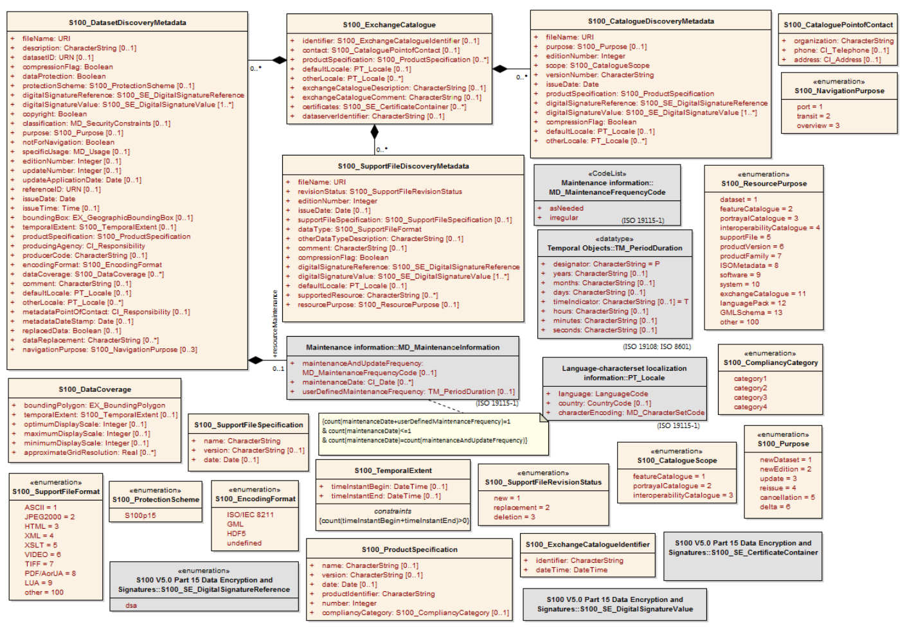
Figure 19-3 – S-129 Exchange catalogue and discovery metadata
NOTE 1: Types with CI, EX, and MD prefixes are from packages defined in ISO 19115-1 and 19115-3 and adapted by S-100. Types with S100 prefix are from packages defined in S-100.
NOTE 2: When a dataset is terminated, the purpose metadata field is set to 3 (terminated), and the editionNumber metadata field is set to 0. All inapplicable but mandatory metadata fields must be nulled.

Page intentionally left blank

S100_ExchangeCatalogue
Each exchange set has a single S100_ExchangeCatalogue which contains meta information for the data and support files in the exchange set.
This class is inherited from S100_ExchangeCatalogue, as detailed in S-100 Part 17, Clause 17-4.5, with certain attributes and roles restricted as described below.
Role Name | Name | Description | Mult | Type | Remarks
Class | S100_ExchangeCatalogue | An exchange catalogue contains the discovery metadata about the exchange datasets and support files | - | - | -
Attribute | identifier | Uniquely identifies this exchange catalogue | 1 | S100_ExchangeCatalogueIdentifier
Attribute | contact | Details about the issuer of this exchange catalogue | 1 | S100_CataloguePointOfContact
Attribute | productSpecification | Details about the Product Specifications used for the datasets contained in the Exchange Catalogue | 1 | S100_ProductSpecification | Conditional on all the datasets using the same product specification
Attribute | defaultLocale | Default language and character set used for all metadata records in this Exchange Catalogue | 1 | PT_Locale | Default is English and UTF-8
Attribute | otherLocale | Other languages and character sets used for the localized metadata records in this Exchange Catalogue | 0..* | PT_Locale | Required if any localized entries are present in the Exchange Catalogue
Attribute | exchangeCatalogueDescription | Description of what the exchange catalogue contains | 1 | CharacterString
Attribute | exchangeCatalogueComment | Any additional Information | 0..1 | CharacterString
Attribute | certificates | Signed public key certificates referred to by digital signatures in the Exchange Set | 0..* | S100_SE_CertificateContainer | Content defined in S-100 Part 15. All  certificates used, except the SA root  certificate (installed separately by the implementing system) shall be included
Attribute | dataServerIdentifier | Identifies the data server for the permit | 0..1 | CharacterString
Role | datasetDiscoveryMetadata | Exchange catalogues may include or reference discovery metadata for the datasets in the exchange set | 0..* | Aggregation S100_DatasetDiscoveryMetadata
Role | catalogueDiscoveryMetadata | Metadata for catalogue | 0..* | Aggregation S100_CatalogueDiscoveryMetadata | Metadata for the feature, portrayal, and interoperability catalogues, if any
Role | supportFileDiscoveryMetadata | Exchange catalogues may include or reference discovery metadata for the support files in the exchange set | 0..* | Aggregation S100_SupportFileDiscoveryMetadata

S100_ExchangeCatalogueIdentifier
S-129 uses S100_ExchangeCatalogueIdentifer as detailed in S-100 Part 17, Clause 17-4.5, without modification.

S100_CataloguePointofContact
S-129 uses S100_CataloguePointofContact as detailed in S-100 Part 17, Clause 17-4.5, without modification.

S100_DatasetDiscoveryMetadata
This class is inherited from S100_DatasetDiscoveryMetadata, as detailed in S-100 Part 17, Clause 17-4.5, with certain attributes and roles restricted as described below.
Role Name | Name | Description | Mult | Type | Remarks
Class | S100_DatasetDiscoveryMetadata | Metadata about the individual datasets in the exchange catalogue | - | - | -
Attribute | fileName | Dataset file name | 1 | URI
Attribute | description | Short description giving the area or location covered by the dataset | 0..1 | CharacterString | For example, a harbour or port name, between two named locations etc
Attribute | datasetID | Dataset ID expressed as a Marine Resource Name | 0..1 | URN | The URN must be an MRN
Attribute | compressionFlag | Indicates if the resource is compressed | 1 | Boolean | True indicates a compressed dataset resource  False indicates an uncompressed dataset resource
Attribute | dataProtection | Indicates if the data is encrypted | 1 | Boolean | True indicates an encrypted dataset resource  False indicates an unencrypted dataset resource
Attribute | protectionScheme | Specification or method used for data protection | 0..1 | S100_ProtectionScheme
Attribute | digitalSignatureReference | Specifies the algorithm used to compute digitalSignatureValue | 1 | S100_SE_DigitalSignatureReference (see Part 15) | Specifies the algorithm used to compute digitalSignatureValue
Attribute | digitalSignatureValue | Value derived from the digital signature | 1..* | S100_SE_DigitalSignature | The value resulting from application of digitalSignatureReference
Attribute | copyright | Indicates if the dataset is copyrighted | 1 | Boolean | True indicates the resource is copyrighted  False Indicates the resource is not copyrighted
Attribute | classification | Indicates the security classification of the dataset | 0..1 | Class MD_SecurityConstraints>MD_ClassificationCode (codelist) | 1. unclassified  2. restricted  3. confidential  4. secret  5. top secret  6. sensitive but unclassified  7. for official use only  8. protected  9. limited distribution
Attribute | purpose | The purpose for which the dataset has been issued | 1 | S100_Purpose
Attribute | notForNavigation | Indicates the dataset is not intended to be used for navigation | 1 | Boolean | True indicates the dataset is not intended to be used for navigation  False indicates the dataset is intended to be used for navigation
Attribute | specificUsage | The use for which the dataset is intended | 1 | MD_USAGE>specificUsage (character string) | For navigation through <name of UKCM Operational Area> by <ship name>.
Attribute | editionNumber | The Edition number of the dataset | 1 | Integer | When a dataset is initially created, the Edition number 1 is assigned to it. The Edition number is increased by 1 at each new Edition. Edition number remains the same for a re-issue
Attribute | updateNumber | Update number assigned to the dataset and increased by one for each subsequent update | 0..1 | Integer | Update number 0 is assigned to a new dataset
Attribute | updateApplicationDate | This date is only used for the base cell files (that is new dataset, re-issue and new edition), not update cell files. All updates dated on or before this date must have been applied by the producer | 0..1 | Date
Attribute | referenceID | Reference back to the datasetID | 0..1 | URN | Update metadata refers to the datasetID of the dataset metadata. This is used if and only if the dataset is an update  The URN must be an MRN
Attribute | issueDate | Date on which the data was made available by the data producer | 1 | Date
Attribute | issueTime | Time of day at which the data was made available by the data producer | 1 | Time | The S-100 datatype Time
Attribute | boundingBox | The extent of the dataset limits | 0..1 | EX_GeographicBoundingBox | -
Attribute | temporalExtent | Specification of the temporal extent of the dataset. | 1 | S100_TemporalExtent | The temporal extent is encoded as the date/time of the earliest and latest data records (in coverage datasets) or date/time ranges (in vector datasets)  If there is more than one feature in a dataset, the earliest and latest time values of records in all features are used, which means the earliest and latest values may be from different features  If date/time information for a feature is not encoded in the dataset, it is treated for the purposes of this attribute as extending indefinitely in the appropriate direction on the time axis, limited by the issue date/time or the cancellation or supersession of the dataset  This attribute is encoded if and only if at least one of the start and end of the temporal extent is known
Attribute | productSpecification | The product specification used to create this dataset | 1 | S100_ProductSpecification
Attribute | producingAgency | Agency responsible for producing the data | 1 | CI_Responsibility>CI_Organisation | See Table 17-3, S-100 Ed. 5.2.1
Attribute | producerCode | The official IHO Producer Code from S-62 | 0..1 | CharacterString
Attribute | encodingFormat | The encoding format of the dataset | 1 | S100_EncodingFormat | Must be GML
Attribute | dataCoverage | Provides information about data coverages within the dataset | 1..* | S100_DataCoverage
Attribute | comment | Any additional information | 0..1 | CharacterString
Attribute | defaultLocale | Default language and character set used in the dataset | 1 | PT_Locale | In absence of defaultLocale the language is English, UTF-8
Attribute | otherLocale | Other languages and character sets used in the dataset | 0..* | PT_Locale
Attribute | metadataPointOfContact | Point of contact for metadata | 0..1 | CI_Responsibility>CI_Individual or  CI_Responsibility>CI_Organisation | Only if metadataPointOfContact is different to producingAgency
Attribute | metadataDateStamp | Date stamp for metadata | 1 | Date | May or may not be the issue date
Attribute | replacedData | If a data file is cancelled is it replaced by another data file | 0..1 | Boolean
Attribute | dataReplacement | Cell name | 0..* | CharacterString | A dataset may be replaced by 1 or more datasets
Attribute | navigationPurpose | Classification of intended navigation purpose (for Catalogue indexing purposes) | 0..3 | S100_NavigationPurpose | If Product Specification is intended for creation of navigational products this attribute should be mandatory
Role | resourceMaintenance | Information about the frequency of resource updates, and the scope of those updates | 0..1 | MD_MaintenanceInformation | S-100 restricts the multiplicity to 0..1 and adds specific restrictions on the ISO 19115 structure and content. See clause MD_MaintenanceInformation later in this Part  Format: PnYnMnDTnHnMnS (XML builtin type for ISO 8601 duration). See clause 17-4.9

S100_DataCoverage
S-129 uses S100_ DataCoverage as detailed in S-100 Part 17, Clause 17-4.5, without modification.

S100_NavigationPurpose
S-129 uses S100_NavigationPurpose enumeration as detailed in S-100 Part 17, Clause 17-4.5, without modification.

S100_Purpose
S-129 uses S100_Purpose as detailed in S-100 Part 17, Clause 17-4.5, without modification.

S100_TemporalExtent
S-129 uses S100_TemporalExtent as detailed in S-100 Part 17, Clause 17-4.5, without modification.

S100_EncodingFormat
S-129 uses S100_EncodingFormat with a restriction on the allowed values to permit only the S-100 GML format for S-129 datasets.
Role Name | Name | Description | Code | Remarks
Enumeration | S100_EncodingFormat | The encoding format | - | Only value permitted in S-129 is GML, therefore the rest are removed.
Value | GML | The GML data format as defined in Part 10b |  | -

S100_ProductSpecification
This class is inherited from S100_ProductSpecification, as detailed in S-100 Part 17, Clause 17-4.5, with certain attributes and roles restricted as described below.
Role Name | Name | Description | Mult | Type | Remarks
Class | S100_ProductSpecification | The Product Specification contains the information needed to build the specified product | - | - | -
Attribute | name | The name of the product specification used to create the datasets | 1 | CharacterString | 129
Attribute | version | The version number of the product specification | 1 | CharacterString | 1.1.0
Attribute | date | The version date of the product specification | 1 | Date | CCYYMMDD
Attribute | productIdentifer | Machine readable unique identifier of a product type | 1 | CharacterString  (Restricted to Product ID values from the IHO Product Specification Register, in the IHO Geospatial Information Registry) | “S-129”
Attribute | number | The number (registry index) used to lookup the product in the product specification GI registry | 1 | Integer | From the Product Specification Register in the IHO Geospatial Information Registry
Attribute | compliancyCategory | The level of compliance of the Product Specification to S-100 | 0..1 | S100_CompliancyCategory | See S-100 Part 4a, clause 4a-5.5

S100_CompliancyCategory
S-129 uses S100_ComliancyCategory enumeration as detailed in S-100 Part 17, Clause 17-4.5, without modification.

S100_ProtectionScheme
S-129 uses S100_ProtectionScheme enumeration as detailed in S-100 Part 17, Clause 17-4.5, without modification.

S100_SupportFileDiscoveryMetadata
S-129 uses S100_SupportFileDiscoveryMetadata as detailed in S-100 Part 17, Clause 17-4.5, without modification.

S100_SupportFileFormat
S-129 uses S100_SupportFileFormat enumeration as detailed in S-100 Part 17, Clause 17-4.5, without modification.

S100_SupportFileRevisionStatus
S-129 uses S100_SupportFileRevisionStatus enumeration as detailed in S-100 Part 17, Clause 17-4.5, without modification.

S100_SupportFileSpecification
S-129 uses S100_SupportFileSpecification as detailed in S-100 Part 17, Clause 17-4.5, without modification.

S100_ResourcePurpose
S-129 uses S100_ResourcePurpose enumeration as detailed in S-100 Part 17, Clause 17-4.5, without modification.

S100_CatalogueDiscoveryMetadata
This class is inherited from S100_CatalogueDiscoveryMetadata, as detailed in S-100 Part 17, Clause 17-4.5, with certain attributes and roles restricted as described below.
Role Name | Name | Description | Mult | Type | Remarks
Class | S100_CatalogueDiscoveryMetadata | Class for S-100 catalogue metadata. | - | - | -
Attribute | fileName | The name for the catalogue | 1 | URI
Attribute | purpose | The purpose for which the Catalogue has been issued | 0..1 | S100_Purpose  (codelist) | The values must be one of the following:  2 new edition  5 cancellation  Default is new edition
Attribute | editionNumber | The Edition number of the Catalogue | 1 | Integer | Initially set to 1 for a given productSpecification.number  Increased by 1 for each subsequent newEdition  Uniquely identifies the version of the Catalogue
Attribute | scope | Subject domain of the catalogue | 1 | S100_CatalogueScope
Attribute | versionNumber | The version number of the product specification | 1 | CharacterString | Human readable version identifier
Attribute | issueDate | The version date of the product specification | 1 | Date
Attribute | productSpecification | The product specification used to create this file | 1 | S100_ProductSpecification
Attribute | digitalSignatureReference | Specifies the algorithm used to compute digitalSignatureValue | 1 | S100_DigitalSignatureReference  (see Part 15)
Attribute | digitalSignatureValue | Value derived from the digital signature | 1..* | S100_DigitalSignatureValue  (see Part 15) | The value resulting from application of digitalSignatureReference  Implemented as the digital signature format specified in Part 15
Attribute | compressionFlag | Indicates if the resource is compressed | 1 | Boolean | True indicates a compressed resource  False indicates an uncompressed resource
Attribute | defaultLocale | Default language and character set used in the Catalogue | 1 | PT_Locale | In absence of defaultLocale the language is English in UTF-8
Attribute | otherLocale | Other languages and character sets used in thecatalogue | 0..* | PT_Locale

S100_CatalogueScope
S-129 uses S100_CatalogueScope enumeration as detailed in S-100 Part 17, Clause 17-4.5, without modifications.

Page intentionally left blank

- Data Classification and Encoding Guide
- UnderKeelClearancePlan
IHO Definition: UKC plans are specific to a ship and a UKCM Operational Area. There are three kinds of plan: a Pre-plan, an Actual Plan and an Actual Update.
S-129 Metadata Feature: UnderKeelClearancePlan
Super Type:
Primitive: noGeometry
Real World | Paper Chart Symbol |  | ECDIS Symbol
S-129 Attribute | S-57 Acronym | Allowable Encoding Value | Type | Multiplicity
Generation Time |  |  | DT | 0, 1
Vessel ID |  |  | TE | 0, 1
Source Route Name |  |  | TE | 0, 1
Source Route Version |  |  | IN | 0, 1
Maximum Draught |  |  | RE | 0, 1
Under Keel Clearance Purpose |  | 1: Pre Plan  2: Actual Plan  3: Actual Update | EN | 0, 1
Under Keel Clearance Calculation Requested |  | 1: Time Window  2: Maximum Draught | EN | 0, 1
Interoperability Identifier |  |  | URN | 0, *
Fixed Time Range |  |  | C | 0, 1
Time Start |  |  | (S) DT | 0, 1
Time End |  |  | (S) DT | 0, 1
Introductory remarks.
There are three kinds of UKC plans:
- a Pre-plan is a set of tidal windows available for a ship to transit through a UKCM Operational Area, at a specified draught
- an Actual Plan is specific to a ship and a UKCM Operational Area for a waterway, and contains a route defined by a set of geographical control points with time windows for each control point, and non-navigable and almost non-navigable areas, and
- an Actual Update is a replacement Actual Plan.

Feature/Information associations
Type | Association Name | Association Ends
 |  | Class | Role | Mult
Asso | UKC Plan Area Composition | UnderKeelClearancePlanArea | theComponent | 0, *
Asso | UKC Non Navigable Area Composition | UnderKeelClearanceNonNavigableArea | theComponent | 0, *
Asso | UKC Almost Non Navigable Area Composition | UnderKeelClearanceAlmostNonNavigableArea | theComponent | 0, *
Asso | UKC Control Point Composition | UnderKeelClearanceControlPoint | theComponent | 1, *

- UnderKeelClearancePlanArea
IHO Definition: The area for which an under keel clearance plan has been calculated for a particular vessel, for a particular passage.
S-129 Geo Feature: UnderKeelClearancePlanArea
Super Type:
Primitive: surface
Real World | Paper Chart Symbol |  | ECDIS Symbol
S-129 Attribute | S-57 Acronym | Allowable Encoding Value |  | Type | Multiplicity
Scale Minimum | (SCAMIN) |  |  | IN | 0, 1
Interoperability Identifier |  |  |  | URN | 0, *
Introductory remarks. The Under Keel Clearance Plan area is spatial information which are included in Actual Plans and Actual Updates. It encompasses under keel clearance non-navigable areas, almost non-navigable areas, and navigable areas.

Feature/Information associations
Type | Association Name | Association Ends
 |  | Class | Role | Mult
Comp | UKC Plan Area Composition | UnderKeelClearancePlan | theCollection | 1, 1

- UnderKeelClearanceNonNavigableArea
IHO Definition: An area within a UKCM Operational Area where UKC for a specific ship is calculated to be less than the UKC limit for the waterway.
S-129 Geo Feature: UnderKeelClearanceNonNavigableArea
Super Type:
Primitive: surface
Real World | Paper Chart Symbol |  | ECDIS Symbol
S-129 Attribute | S-57 Acronym | Allowable Encoding Value |  | Type | Multiplicity
Scale Minimum | (SCAMIN) |  |  | IN | 0, 1
Interoperability Identifier |  |  |  | URN | 0, *
Introductory remarks. Non-navigable areas are spatial information which are included in Actual Plans and Actual Updates.

Feature/Information associations
Type | Association Name | Association Ends
 |  | Class | Role | Mult
Comp | UKC Non Navigable Area Composition | UnderKeelClearancePlan | theCollection | 1, 1

- UnderKeelClearanceAlmostNonNavigableArea
IHO Definition: An area within a UKCM Operational Area where UKC for a specific ship is calculated to be approaching the UKC limit for the waterway (within a specified value range).
S-129 Geo Feature: UnderKeelClearanceAlmostNonNavigableArea
Super Type:
Primitive: surface
Real World | Paper Chart Symbol |  | ECDIS Symbol
S-129 Attribute | S-57 Acronym | Allowable Encoding Value |  | Type | Multiplicity
Scale Minimum | (SCAMIN) |  |  | IN | 0, 1
Distance Above UKC Limit |  |  |  | RE | 0, 1
Interoperability Identifier |  |  |  | URN | 0, *
Introductory remarks. Almost non-navigable areas are spatial information which are included in Actual Plans and Actual Updates.

Feature/Information associations
Type | Association Name | Association Ends
 |  | Class | Role | Mult
Comp | UKC Almost Non Navigable Area Composition | UnderKeelClearancePlan | theCollection | 1, 1

- UnderKeelClearanceControlPoint
IHO Definition: A geographical position denoting a point along a specific ship’s route within a UKCM Operational Area where the ship must pass within a time range or time window (for example start and end time) calculated by the UKCM Service Provider.
S-129 Geo Feature: UnderKeelClearanceControlPoint
Super Type:
Primitive: point
Real World | Paper Chart Symbol |  | ECDIS Symbol
S-129 Attribute | S-57 Acronym | Allowable Encoding Value |  | Type | Multiplicity
Distance Above UKC Limit |  |  |  | RE | 0, 1
Feature Name |  |  |  | C | 0, 1
Language |  |  |  | (S) TE | 1
Name |  |  |  | (S) TE | 1
Name Usage |  | 1: Default Name Display  2: Alternate Name Display |  | (S) EN | 0, 1
Expected Passing Time |  |  |  | DT | 0, 1
Expected Passing Speed |  |  |  | RE | 0, 1
Interoperability Identifier |  |  |  | URN | 0, *
Fixed Time Range |  |  |  | C | 0, 1
Time Start |  |  |  | (S) DT | 0, 1
Time End |  |  |  | (S) DT | 0, 1
Introductory remarks. Control points are included in Actual Plans and Actual Updates.

Feature/Information associations
Type | Association Name | Association Ends
 |  | Class | Role | Mult
Comp | UKC Control Point Composition | UnderKeelClearancePlan | theCollection | 1, 1

- Association Names
- UKC Plan Area Composition
IHO Definition: A feature association for the binding between Under Keel Clearance Plan Area and Under Keel Clearance Plan
Remarks:
•No remarks.
Role Type | Role | Associated With | Multiplicity
Composition | The Component | Under Keel Clearance Plan Area | 0, *
 | The Collection | Under Keel Clearance Plan | 1, 1

- UKC Non Navigable Area Composition
IHO Definition: A feature association for the binding between Under Keel Clearance Non Navigable Area and Under Keel Clearance Plan
Remarks:
•No remarks.
Role Type | Role | Associated With | Multiplicity
Composition | The Component | Under Keel Clearance Non Navigable Area | 0, *
 | The Collection | Under Keel Clearance Plan | 1, 1

- UKC Almost Non Navigable Area Composition
IHO Definition: A feature association for the binding between Under Keel Clearance Almost Non Navigable Area and Under Keel Clearance Plan
Remarks:
•No remarks.
Role Type | Role | Associated With | Multiplicity
Composition | The Component | Under Keel Clearance Almost Non Navigable Area | 0, *
 | The Collection | Under Keel Clearance Plan | 1, 1

- UKC Control Point Composition
IHO Definition: A feature association for the binding between Under Keel Clearance Control Point and Under Keel Clearance Plan
Remarks:
•No remarks.
Role Type | Role | Associated With | Multiplicity
Composition | The Component | Under Keel Clearance Control Point | 1, *
 | The Collection | Under Keel Clearance Plan | 1, 1

- Association Roles
- The Collection
IHO Definition: A pointer to the aggregate in a whole-part relationship.

- The Component
IHO Definition: A pointer to a part in a whole-part relationship

- Attribute and Enumerate Descriptions
- Generation Time
IHO Definition: Time the UKC plan was generated.

Remarks:
•No remarks.

- Vessel ID
IHO Definition: Vessel identifier, based on MRN. Can be either IMO or MMSI based.

Remarks:
•No remarks.

- Source Route Name
IHO Definition: Identification of the route used as a source for the calculation.

Remarks:
May be provided through different methods, such as S-421, RTZ, or as generated by the UKCM service.
If provided, for example, using S-421, the value of “S-421.Route.routeID” is used for machine-readable identification, or the value of “S-421.RouteInfo.routeInfoName” is used for human-readable identification.

- Source Route Version
IHO Definition: Identification of the route used as a source for the calculation.

Remarks:
May be provided through different methods, such as S-421, RTZ, or as generated by the UKCM service.
Can be used to supplement information provided by “sourceRouteName”, especially if “sourceRouteName” provides insufficient route information.
If provided, for example, using S-421, the value of “S-421.Route.routeEditionNo” is used.

- Maximum Draught
IHO Definition: The maximum vessel draught in metres, used as base for the calculation.

Remarks:
•No remarks.

- Scale Minimum
IHO Definition: The minimum scale at which the feature may be used for example for ECDIS presentation.

Remarks:
The modulus of the scale is indicated, that is 1:1 250 000 is encoded as 1250000.

- Language
IHO Definition: The method of human communication, either spoken or written, consisting of the use of words in a structured and conventional way.

Remarks:
•No remarks.

- Name
IHO Definition: The individual name of a feature.

Remarks:
•No remarks.

- Name Usage
IHO Definition: Classification of the type and display level of the name of a feature in an end-user system.
1) defaultNameDisplay
IHO Definition: The name is intended to be displayed when the end-user system is set to the default name/text display setting.
2) alternateNameDisplay
IHO Definition: The name is intended to be displayed when the end-user system is set to an alternate name/text display setting, for example an alternate language.

Remarks:
•No remarks.

- Expected Passing Time
IHO Definition: The expected passing time for a ship for a nominated Under Keel Clearance Control Point.

Remarks:
•No remarks.

- Expected Passing Speed
IHO Definition: The expected passing speed for a ship for a nominated Under Keel Clearance Control Point.

Remarks:
•No remarks.

- Time Start
IHO Definition: The start time of an active period.

Remarks:
•No remarks.

- Time End
IHO Definition: The end time of an active period.

Remarks:
•No remarks.

- Distance Above UKC Limit
IHO Definition: The distance of the lowest part of the ship's keel above the established Under Keel Clearance Limit for the waterway, expressed in metres.

Remarks:
•No remarks.

- Interoperability Identifier
IHO Definition: A common unique identifier for entities which describe a single real-world feature, and which is used to identify instances of the feature in end-user systems where the feature may be included in multiple data product types.

Remarks:
•No remarks.

- Under Keel Clearance Purpose
IHO Definition: The relevant phase of a UKC passage plan.
1) Pre Plan
IHO Definition: An indicative UKC plan that identifies potential sailing windows for a nominated vessel draught; days, weeks or months prior to the planned passage through the UKCM region.
2) Actual Plan
IHO Definition: A detailed Under Keel Clearance plan that identifies sailing windows and no-go areas, integrating live weather data, hours or days prior to transiting the Under Keel Clearance Management region.
3) Actual Update
IHO Definition: A near real-time, detailed, Under Keel Clearance plan that identifies sailing windows and no-go areas, using live weather, vessel position and traffic data, while the vessel is transiting the Under Keel Clearance Management region.

Remarks:
•No remarks.

- Under Keel Clearance Calculation Requested
IHO Definition: Indication of the aim of the UKC plan: To find the maximum safe vessel draught for transiting the UKCM region, or to find sailing windows for a nominated vessel draught.
1) Time Window
IHO Definition: The available time window(s) for a given draught.
2) Maximum Draught
IHO Definition: The maximum draught for a given time window.

Remarks:
•No remarks.

Page intentionally left blank

- Schema documentation for S129.xsd
- Schema(s)
- Main schema S129.xsd
Namespace | http://www.iho.int/S129/gml/cs0/0.1
Properties | attribute form default: | unqualified
 | element form default: | unqualified
 | version: | 0.1-20180531

- Complex Type(s)
- Complex Type — GM_Point
Namespace | http://www.iho.int/S129/gml/cs0/0.1
Diagram | 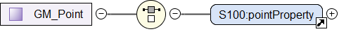
Used by | Element UnderKeelClearanceControlPointType/geometry
Model | pointProperty
Children | pointProperty

- Complex Type — GM_Surface
Namespace | http://www.iho.int/S129/gml/cs0/0.1
Diagram
Used by | Elements UnderKeelClearanceAlmostNonNavigableAreaType/geometry, UnderKeelClearanceNonNaviga- bleAreaType/geometry, UnderKeelClearancePlanAreaType/geometry
Model | surfaceProperty
Children | surfaceProperty

- Complex Type — fixedTimeRangeType
Namespace | http://www.iho.int/S129/gml/cs0/0.1
Annotations | Time interval
Diagram | 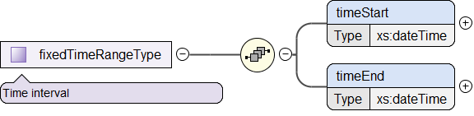
Used by | Elements UnderKeelClearanceControlPointType/fixedTimeRange, UnderKeelClearancePlanType/fixed- TimeRange
Model | timeStart , timeEnd
Children | timeEnd, timeStart

- Complex Type — featureNameType
Namespace | http://www.iho.int/S129/gml/cs0/0.1
Annotations | Provides the name of an entity, defines the national language of the name, and provides the option to display the name at various system display settings.
Diagram | 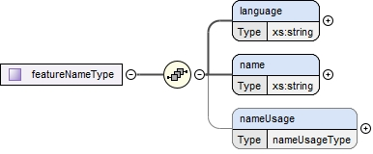
Used by | Elements UnderKeelClearanceControlPointType/featureName
Model | language, name, nameUsage
Children | language, name, nameUsage

- Complex Type — FeatureType
Namespace | http://www.iho.int/S129/gml/cs0/0.1
Annotations | Generalized feature type which carries all the common attributes
Diagram | 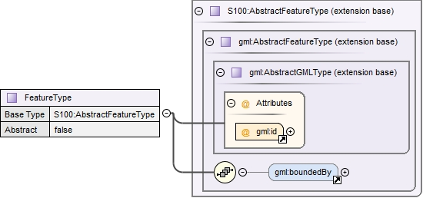
Type | extension of AbstractFeatureType
Type  hierarchy | - gml:AbstractGMLType  - gml:AbstractFeatureType  - AbstractFeatureType  - FeatureType
Properties | abstract: true
Used by | Element FeatureType
 | Complex Types UnderKeelClearanceAlmostNonNavigableAreaType, UnderKeelClearanceControlPointType, Under- KeelClearanceNonNavigableAreaType, UnderKeelClearancePlanAreaType, UnderKeelClearancePlanType
Model | gml:boundedBy{0,1} , featureObjectIdentifier{0,1} , informationAssociation* , featureAssociation* , invFeatureAssociation*
Children | featureAssociation, featureObjectIdentifier, gml:boundedBy, informationAssociation, invFeatureAssociation
Attributes | QName | Type | Use
 | gml:id | ID | required
 |  | The attribute gml:id supports provision of a handle for the XML element representing a GML Object. Its use is mandatory for all GML objects. It is of XML type ID, so is constrained to be unique in the XML document within which it occurs.

- Complex Type — UnderKeelClearancePlanType
Namespace | http://www.iho.int/S129/gml/cs0/0.1
Annotations | A UKC plan calculated for a particular vessel, for a particular passage.
Diagram | 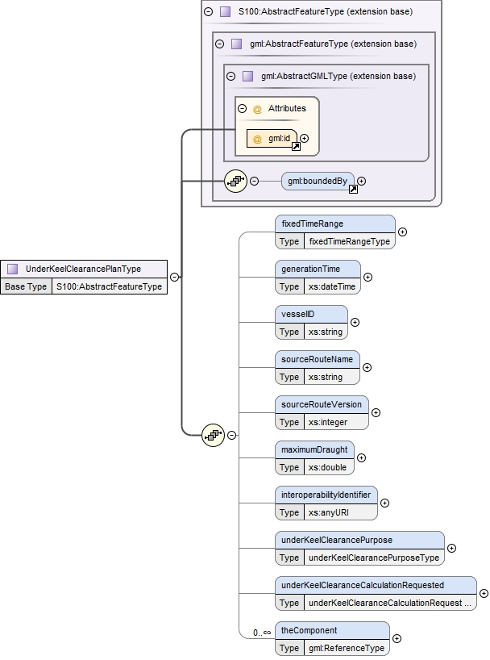
Type | extension of FeatureType
Type  hierarchy | - gml:AbstractGMLType  - gml:AbstractFeatureType  - AbstractFeatureType  - FeatureType  - UnderKeelClearancePlanType
Used by | Element UnderKeelClearancePlan
Model | gml:boundedBy{0,1} , fixedTimeRange , generationTime , vesselID , sourceRouteName , sourceRouteVersion , maximumDraught , underKeelClearancePurpose , underKeelClearanceCalculationRequested , interoperabilityIdentifier, theComponent+
Children | fixedTimeRange, generationTime, gml:boundedBy, interoperabilityIdentifier, maximumDraught, sourceRouteName, sourceRouteVersion, theComponent, underKeelClearanceCalculationRequested, underKeelClearancePurpose, vesselID
Attributes | QName | Type | Use
 | gml:id | ID | required
 |  | The attribute gml:id supports provision of a handle for the XML element representing a GML Object. Its use is mandatory for all GML objects. It is of XML type ID, so is constrained to be unique in the XML document within which it occurs.

- Complex Type – UnderKeelClearancePlanAreaType
Namespace | http://www.iho.int/S129/gml/cs0/0.1
Annotations | The area for which an under keel clearance plan has been calculated for a particular vessel, for a particular passage.
Diagram | 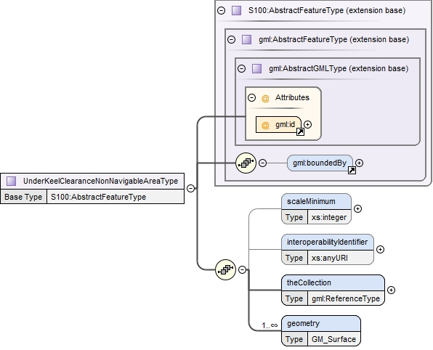
Type | extension of FeatureType
Type  hierarchy | - gml:AbstractGMLType  - gml:AbstractFeatureType  - AbstractFeatureType  - FeatureType  - UnderKeelClearancePlanAreaType
Used by | Element UnderKeelClearancePlanArea
Model | gml:boundedBy{0,1}, scaleMinimum, interoperabilityIdentifier, geometry, theCollection+
Children | geometry, gml:boundedBy, interoperabilityIdentifier, scaleMinimum, theCollection
Attributes | QName | Type | Use
 | gml:id | ID | required
 |  | The attribute gml:id supports provision of a handle for the XML element representing a GML Object. Its use is mandatory for all GML objects. It is of XML type ID, so is constrained to be unique in the XML document within which it occurs.

- Complex Type — UnderKeelClearanceNonNavigableAreaType
Namespace | http://www.iho.int/S129/gml/cs0/0.1
Annotations | An area of under keel clearance less than the calculated safe limit.
Diagram | 
Type | extension of FeatureType
Type  hierarchy | - gml:AbstractGMLType  - gml:AbstractFeatureType  - AbstractFeatureType  - FeatureType  - UnderKeelClearanceNonNavigableAreaType
Used by | Element UnderKeelClearanceNonNavigableArea
Model | gml:boundedBy{0,1}, scaleMinimum , interoperabilityIdentifier, geometry , theCollection
Children | geometry, gml:boundedBy, interoperabilityIdentifier, scaleMinimum, theCollection
Attributes | QName | Type | Use
 | gml:id | ID | required
 |  | The attribute gml:id supports provision of a handle for the XML element representing a GML Object. Its use is mandatory for all GML objects. It is of XML type ID, so is constrained to be unique in the XML document within which it occurs.

- Complex Type — UnderKeelClearanceAlmostNonNavigableAreaType
Namespace | http://www.iho.int/S129/gml/cs0/0.1
Annotations | An area of under keel clearance almost less than the calculated safe limit, as established for the waterway.
Diagram | 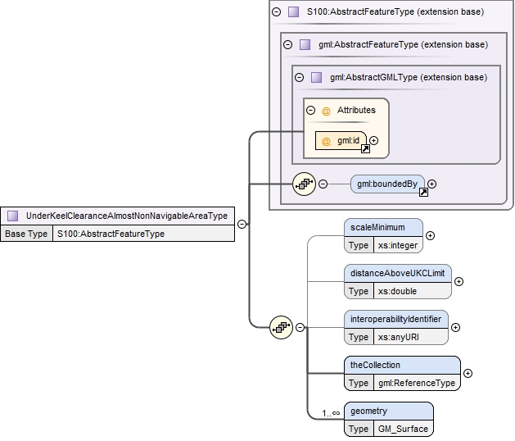
Type | extension of FeatureType
Type  hierarchy | - gml:AbstractGMLType  - gml:AbstractFeatureType  - AbstractFeatureType  - FeatureType  - UnderKeelClearanceAlmostNonNavigableAreaType
Used by | Element UnderKeelClearanceAlmostNonNavigableArea
Model | gml:boundedBy{0,1}, dis- tanceAboveUKCLimit, scaleMinimum, interoperabilityIdentifier, geometry , theCollection
Children | distanceAboveUKCLimit, geometry, gml:boundedBy, interoperabilityIdentifier, theCollection
Attributes | QName | Type | Use
 | gml:id | ID | required
 |  | The attribute gml:id supports provision of a handle for the XML element representing a GML Object. Its use is mandatory for all GML objects. It is of XML type ID, so is constrained to be unique in the XML document within which it occurs.
 | QName

- Complex Type — UnderKeelClearanceControlPointType
Namespace | http://www.iho.int/S129/gml/cs0/0.1
Annotations | Selected critical passage point or line
Diagram | 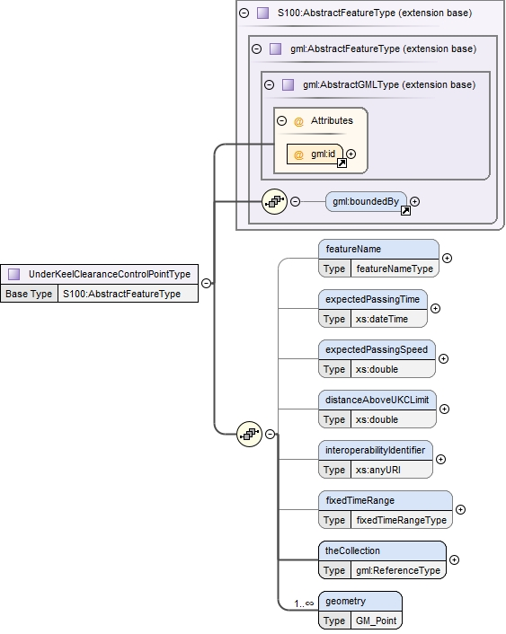
Type | extension of FeatureType
Type  hierarchy | - gml:AbstractGMLType  - gml:AbstractFeatureType  - AbstractFeatureType  - FeatureType  - UnderKeelClearanceControlPointType
Used by | Element UnderKeelClearanceControlPoint
Model | gml:boundedBy{0,1}, distanceAboveUKCLimit{0,1} , expectedPassingSpeed{0,1} , expectedPassingTime{0,1} , featureName{0,1} , fixedTimeRange{0,1} , geometry , theCollection
Children | theCollection, distanceAboveUKCLimit, expectedPassingSpeed, expectedPassingTime, featureName, fixedTimeRange, geometry, gml:boundedBy, name
Attributes | QName | Type | Use
 | gml:id | ID | required
 |  | The attribute gml:id supports provision of a handle for the XML element representing a GML Object. Its use is mandatory for all GML objects. It is of XML type ID, so is constrained to be unique in the XML document within which it occurs.

- Complex Type — InformationTypeType
Namespace | http://www.iho.int/S129/gml/cs0/0.1
Annotations | Generalized information type which carry all the common attributes
Diagram | 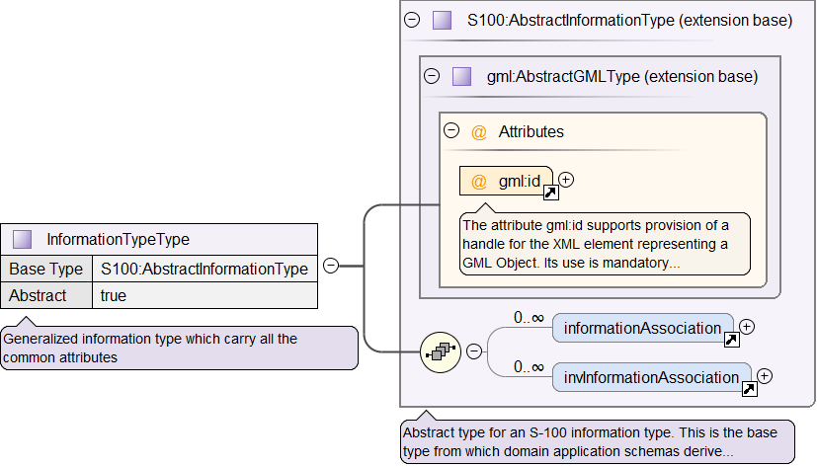
Type | extension of AbstractInformationType
Type  hierarchy | - gml:AbstractGMLType  - AbstractInformationType  - InformationTypeType
Properties | abstract: true
Used by | Element InformationType
Model | informationAssociation* , invInformationAssociation*
Children | informationAssociation, invInformationAssociation
Attributes | QName | Type | Use
 | gml:id | ID | required
 |  | The attribute gml:id supports provision of a handle for the XML element representing a GML Object. Its use is mandatory for all GML objects. It is of XML type ID, so is constrained to be unique in the XML document within which it occurs.

- Complex Type — DatasetType
Namespace | http://www.iho.int/S129/gml/cs0/0.1
Annotations | Dataset element for dataset as "GML document"
Diagram | 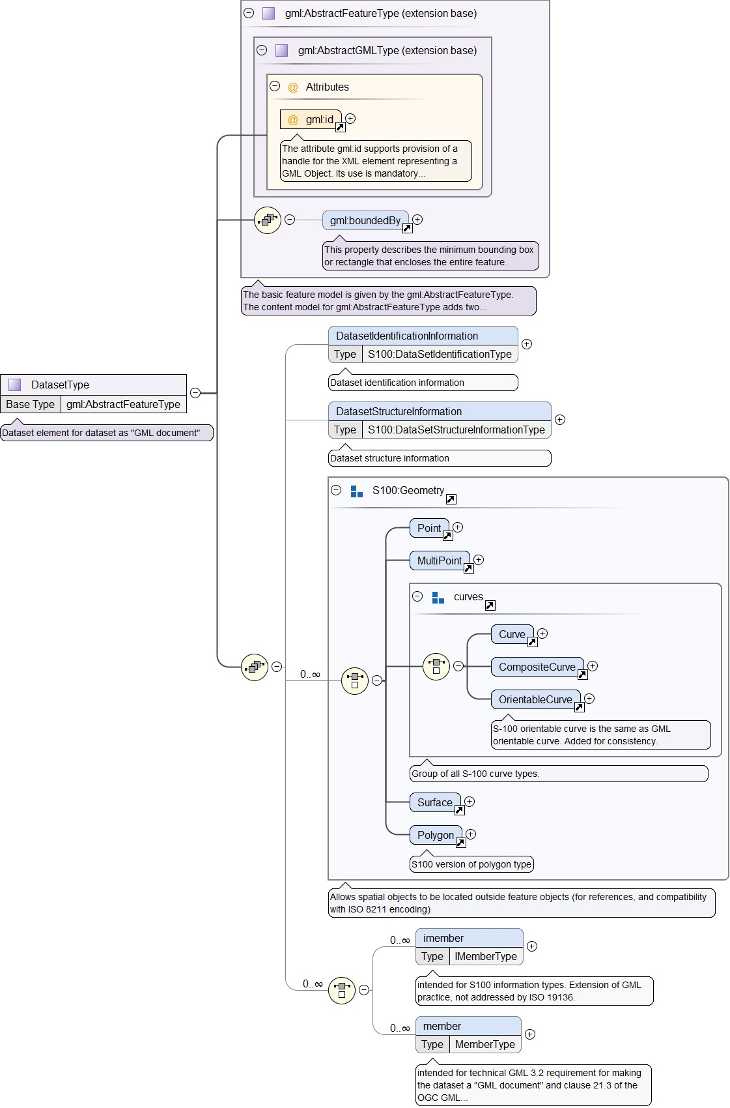
Type | extension of gml:AbstractFeatureType
Type  hierarchy | - gml:AbstractGMLType  - gml:AbstractFeatureType  - DatasetType
Used by | Element DataSet
Model | gml:boundedBy{0,1} , DatasetIdentificationInformation{0,1} , DatasetStructureInformation{0,1} , (Point | MultiPoint | Curve | CompositeCurve | OrientableCurve | Surface | Polygon) , (imember* | member*)
Children | CompositeCurve, Curve, DatasetIdentificationInformation, DatasetStructureInformation, MultiPoint, OrientableCurve, Point, Poly- gon, Surface, gml:boundedBy, imember, member
Attributes | QName | Type | Use
 | gml:id | ID | required
 |  | The attribute gml:id supports provision of a handle for the XML element representing a GML Object. Its use is mandatory for all GML objects. It is of XML type ID, so is constrained to be unique in the XML document within which it occurs.

- Complex Type — IMemberType
Namespace | http://www.iho.int/S129/gml/cs0/0.1
Annotations | dataset member S-100 information types
Diagram | 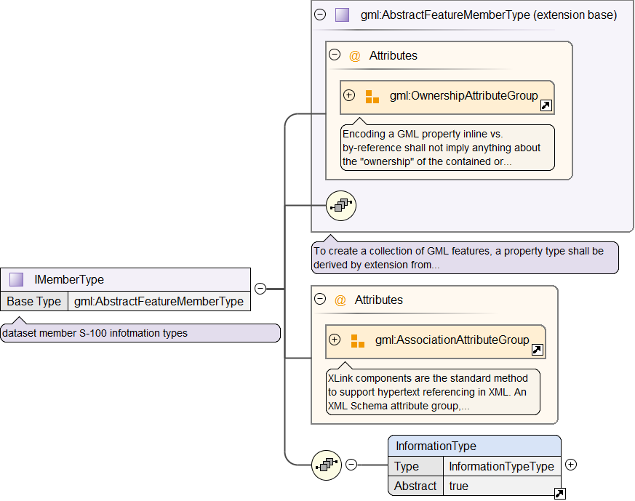
Type | extension of gml:AbstractFeatureMemberType
Type hierar- chy | - gml:AbstractFeatureMemberType  - IMemberType
Used by | Element DatasetType/imember
Model | InformationType
Children | InformationType
Attributes | QName | Type | Fixed Default | Use
 | nilReason | gml:NilReasonType |  | optional
 | owns | boolean | false | optional
 | xlink:actuate | xlink:actuateType |  | optional
 | xlink:arcrole | xlink:arcroleType |  | optional
 | xlink:href | xlink:hrefType |  | optional
 | xlink:role | xlink:roleType |  | optional
 | xlink:show | xlink:showType |  | optional
 | QName | Type | Fixed Default | Use
 | xlink:title | xlink:titleAttrType |  | optional
 | xlink:type | xlink:typeType | simple | optional

- Complex Type — MemberType
Namespace | http://www.iho.int/S129/gml/cs0/0.1
Annotations | dataset member
Diagram  Type | 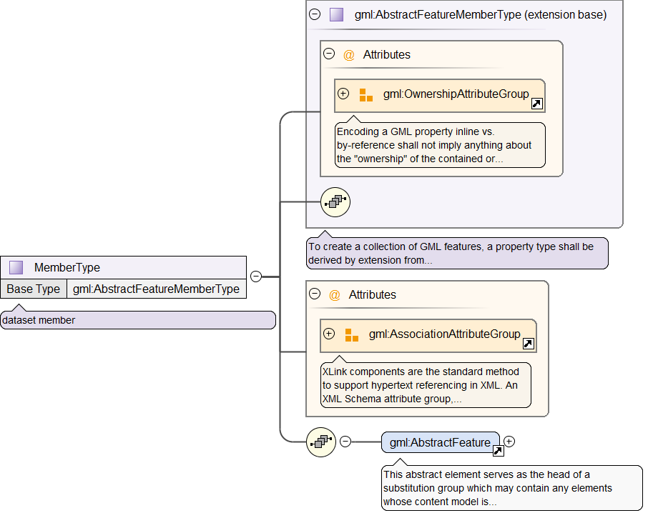  extension of gml:AbstractFeatureMemberType
Type  hierarchy | - gml:AbstractFeatureMemberType  - MemberType
Used by | Element DatasetType/member
Model | gml:AbstractFeature
Children | gml:AbstractFeature
Attributes | QName | Type | Fixed Default | Use
 | nilReason | gml:NilReasonType |  | optional
 | owns | boolean | false | optional
 | xlink:actuate | xlink:actuateType |  | optional
 | xlink:arcrole | xlink:arcroleType |  | optional
 | xlink:href | xlink:hrefType |  | optional
 | xlink:role | xlink:roleType |  | optional
 | xlink:show | xlink:showType |  | optional
 | xlink:title | xlink:titleAttrType |  | optional
 | xlink:type | xlink:typeType | simple | optional

- Complex Type — GenericFeatureType
Namespace | http://www.iho.int/S129/gml/cs0/0.1
Diagram | 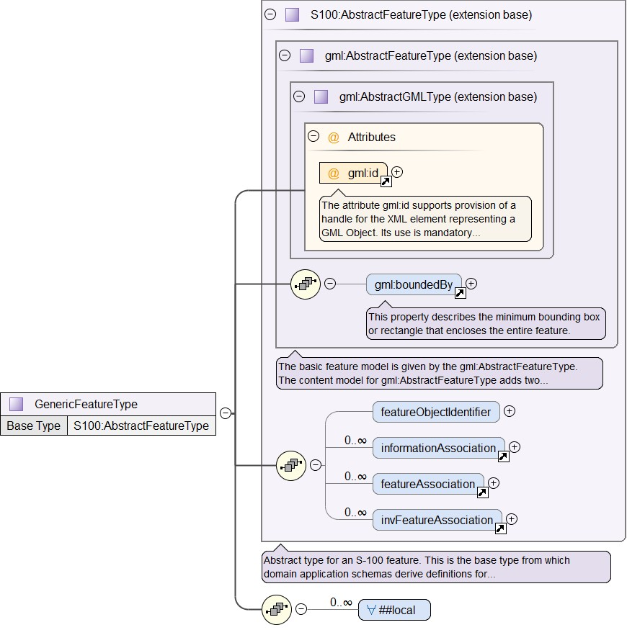
Type | extension of AbstractFeatureType
Type  hierarchy | - gml:AbstractGMLType  - gml:AbstractFeatureType  - AbstractFeatureType  - GenericFeatureType
Model | gml:boundedBy{0,1} , featureObjectIdentifier{0,1} , informationAssociation* , featureAssociation* , invFeatureAssociation* , ANY element from LOCAL namespace 'No Namespace'
Children | featureAssociation, featureObjectIdentifier, gml:boundedBy, informationAssociation, invFeatureAssociation
Attributes | QName | Type | Use
 | gml:id | ID | required
 |  | The attribute gml:id supports provision of a handle for the XML element representing a GML Object. Its use is mandatory for all GML objects. It is of XML type ID, so is constrained to be unique in the XML document within which it occurs.

- Simple Type(s)
- Simple Type — nameUsageType
Namespace | http://www.iho.int/S129/gml/cs0/0.1
Annotations | Classification of the type and display level of the name of a feature in an end-user system.
Diagram | 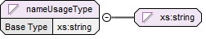
Type | restriction of xs:string
Facets | enumeration | default name display | The name is intended to be displayed when the end-user system is set to the default name/text display setting.
 | enumeration | alternate name display | The name is intended to be displayed when the end-user system is set to an alternate name/text display setting, for example an alternate language.
Used by | Element | nameUsageType

- Simple Type — underKeelClearancePurposeType
Namespace | http://www.iho.int/S129/gml/cs0/0.1
Annotations | The relevant phase of a UKC passage plan
Diagram | 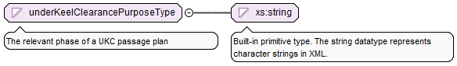
Type | restriction of xs:string
Facets | enumeration | Pre Plan | An indicative UKC plan that identifies potential sailing windows for a nominated vessel draught, days, weeks or months prior to the planned passage through the UKCM region.
 | enumeration | Actual Plan | A detailed UKC plan that identifies sailing windows non-navigable and almost non-navigable areas, integrating live weather data, hours or days prior to transiting the UKCM region.
 | enumeration | Actual Update | A near real-time, detailed, UKC plan that identifies sailing windows and non-navigable and almost non-navigable areas, using live weather, vessel position and traffic data, while the vessel is transiting the UKCM region.
Used by | Element | UnderKeelClearancePlanType/underKeelClearancePurposeType

- Simple Type — underKeelClearanceCalculationRequestedType
Namespace | http://www.iho.int/S129/gml/cs0/0.1
Annotations | Indication of the aim of the UKC plan: to find the maximum safe vessel draught for transiting the UKCM region, or to find sailing windows for a nominated vessel draught
Diagram | 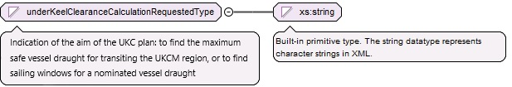
Type | restriction of xs:string
Facets | enumeration Time Window The available time window(s) for a given draught.
 | enumeration | Maximum Draught | The maximum draught for a given time window.
Used by | Element | UnderKeelClearancePlanType/underKeelClearanceCalculationRequestedType

- Feature Catalogue
The Feature catalogue (FC) is a document that describes the content of a data model which is an abstraction of reality that may be used to depict geographic datasets. The FC for S-129 describes the details of Application Schema in clause 7.2 of this Product Specification with GML and it is verified by the FCB (Feature Catalogue Builder) published by KHOA on behalf of IHO.
- Catalogue header information
Name: Under Keel Clearance Management
Scope: Dynamic under keel clearance management information
Field of Application: Under keel clearance management
Version Number: 2.0.1
Version date: 2024-09-28
Producer information:
Individual name:
Organisation name: International Hydrographic Organization
Position Name:
Contact Information:
Phone:
Address:
deliveryPoint | city | administrativeArea | postalCode | country | electronicMailAddress
International Hydrographic Organization,  4 quai Antoine 1er,  B.P. 445 |  |  | MC 98011 MONACO CEDEX
Online resource information:
Hours of Service:
Contact Instructions:
Role: user
Classification: unclassified
- Definition Sources
No definition sources in catalogue.
- Simple Attributes
- Generation Time
Name: Generation Time
Definition: Time the UKC plan was generated.
Code: 'generationTime'
Remarks:
Aliases: (none)
Value Type: dateTime
- Vessel ID
Name: Vessel ID
Definition:
Code: 'vesselID'
Remarks: Vessel identifier, based on MRN. Can be either IMO or MMSI based.
Aliases: (none)
Value Type: text
- Source Route Name
Name: Source Route Name
Definition: Identification of the route used as a source for the calculation.
Code: 'sourceRouteName'
Remarks: May be provided through different methods, such as S-421, RTZ, or as generated by the UKCM service. If provided, for example, using S-421, the value of “S-421.Route.routeID” is used for machine-readable identification, or the value of “S-421.RouteInfo.routeInfoName” is used for human-readable identification.
Aliases: (none)
Value Type: text
- Source Route Version
Name: Source Route Version
Definition: Identification of the route used as a source for the calculation.
Code: 'sourceRouteVersion'
Remarks: May be provided through different methods, such as S-421, RTZ, or as generated by the UKCM service. Can be used to supplement information provided by “sourceRouteName”, especially if “sourceRouteName” provides insufficient route information. If provided, for example, using S-421, the value of “S-421.Route.routeEditionNo” is used.
Aliases: (none)
Value Type: integer
- Maximum Draught
Name: Maximum Draught
Definition: The maximum vessel draught in metres, used as base for the calculation.
Code: 'maximumDraught'
Remarks:
Aliases:
Value Type: real
Unit of measure:
name: metre
symbol: m
Constraints:
String Length | Text Pattern | Range |  | Precision
(not specified) | (none) | lowerBound | 0 | (not specified)
 |  | upperBound | (not specified)
 |  | closure | gtSemiInterval

- Distance Above UKC Limit
Name: Distance Above UKC Limit
Definition: The distance of the lowest part of the ship's keel above the established Under Keel Clearance Limit for the waterway, expressed in metres.
Code: 'distanceAboveUKCLimit'
Remarks:
Aliases:
Value Type: real
Unit of measure:
name: metre
symbol: m

- Scale Minimum
Name: Scale Minimum
Definition: The minimum scale at which the feature may be used for example for ECDIS presentation.
Code: 'scaleMinimum'
Remarks: The modulus of the scale is indicated, that is 1:1 250 000 is encoded as 1250000.
Aliases:
Value Type: integer
- Language
Name: Language
Definition: The method of human communication, either spoken or written, consisting of the use of words in a structured and conventional way.
Code: ‘language’
Remarks:
Aliases:
Value Type: text
- Name
Name: Name
Definition: The individual name of a feature.
Code: ‘name’
Remarks:
Aliases:
Value Type: text
- Expected Passing Time
Name: Expected Passing Time
Definition: The expected passing time for a ship for a nominated Under Keel Clearance Control Point.
Code: 'expectedPassingTime'
Remarks:
Aliases:
Value Type: dateTime
- Expected Passing Speed
Name: Expected Passing Speed
Definition: The expected passing speed for a ship for a nominated Under Keel Clearance Control Point.
Code: 'expectedPassingSpeed'
Remarks:
Aliases:
Value Type: real
Unit of measure:
name: metres per second
symbol: m/s
Constraints:
String Length | Text Pattern | Range |  | Precision
(not specified) | (none) | lowerBound | 0 | (not specified)
 |  | upperBound | (not specified)
 |  | closure | geSemiInterval

- Interoperability Identifier
Name: Interoperability Identifier
Definition: A common unique identifier for entities which describe a single real-world feature, and which is used to identify instances of the feature in end-user systems where the feature may be included in multiple data product types.
Code: ' interoperabilityIdentifier '
Remarks:
Aliases:
Value Type: URN

- Time Start
Name: Time Start
Definition: The start time of an active period.
Code: ‘timeStart’
Remarks:
Aliases:
Value Type: dateTime
- Time End
Name: Time End
Definition: The end time of an active period.
Code: ‘timeEnd’
Remarks:
Aliases:
Value Type: dateTime

- Enumerations
- Name Usage
Name: Name Usage
Definition: Classification of the type and display level of the name of a feature in an end-user system.
Code: 'nameUsage'
Remarks:
Aliases: (none)
Value Type: enumeration
Listed Values
Label | Definition | Code | Remarks
'Default Name Display'  Aliases: (none) | The name is intended to be displayed when the end-user system is set to the default name/text display setting. | 1
'Alternate Name Display'  Aliases: (none) | The name is intended to be displayed when the end-user system is set to an alternate name/text display setting, for example an alternate language. | 2

- Under Keel Clearance Purpose
Name: Under Keel Clearance Purpose
Definition: The relevant phase of a UKC passage plan.
Code: 'underKeelClearancePurpose'
Remarks:
Aliases: (none)
Value Type: enumeration
Listed Values
Label | Definition | Code | Remarks
'Pre Plan'  Aliases: (none) | An indicative UKC plan that identifies potential sailing windows for a nominated vessel draught; days, weeks or months prior to the planned passage through the UKCM region. | 1
'Actual Plan'  Aliases: (none) | A detailed Under Keel Clearance plan that identifies sailing windows and no-go areas, integrating live weather data, hours or days prior to transiting the Under Keel Clearance Management region. | 2
'Actual Update'  Aliases: (none) | A near real-time, detailed, Under Keel Clearance plan that identifies sailing windows and no-go areas, using live weather, vessel position and traffic data, while the vessel is transiting the Under Keel Clearance Management region. | 3

- Under Keel Clearance Calculation Requested
Name: Under Keel Clearance Calculation Requested
Definition: Indication of the aim of the UKC plan: To find the maximum safe vessel draught for transiting the UKCM region, or to find sailing windows for a nominated vessel draught.
Code: 'underKeelClearanceCalculationRequested'
Remarks:
Aliases: (none)
Value Type: Enumeration
Listed Values
Label | Definition | Code | Remarks
'Time Window'  Aliases: (none) | The available time window(s) for a given draught. | 1
'Maximum Draught'  Aliases: (none) | The maximum draught for a given time window. | 2

- Complex Attributes
- Fixed Time Range
Name: Fixed Time Range
Definition: Time interval.
Code: 'fixedTimeRange'
Remarks:
Aliases: (none)
Sub-Attributes
Sub-attribute | Type | Mult. | Permitted Values | sequential
timeStart | dateTime | [0..1] |  | false
timeEnd | dateTime | [0..1] |  | false

- Feature Name
Name: Feature Name
Definition: Provides the name of an entity, defines the national language of the name, and provides the option to display the name at various system display settings.
Code: 'featureName'
Remarks:
Aliases: (none)
Sub-Attributes
Sub-attribute | Type | Mult. | Permitted Values | sequential
language | text | [1] |  | false
name | text | [1] |  | false
nameUsage | enumeration | [0..1] | 1: defaultNameDisplay  2: alternateNameDisplay | false

- Roles
- Associations
Association(name): UKC Plan Area Composition
Definition: A feature association for the binding between Under Keel Clearance Plan Area and Under Keel Clearance Plan
Role Type: Composition
Code: UnderKeelClearancePlanAreaComposition
Multiplicity: 0..* / 1
Role: 'theComponent / theCollection'
Feature type: UnderKeelClearancePlanArea / UnderKeelClearancePlan
Remarks: It must be in all feature types that they have connection. The featuretype attribute is target feature.

Association(name): UKC Non Navigable Area Composition
Definition: A feature association for the binding between Under Keel Clearance Non Navigable Area and Under Keel Clearance Plan
Role type: Composition
Code: UnderKeelClearanceNonNavigableAreaComposition
Multiplicity: 0..* / 1
Role: 'theComponent / theCollection'
Feature type: UnderKeelClearancePlanNonNavigableArea / UnderKeelClearancePlan
Remarks: It must be in all feature types that they have connection. The featuretype attribute is target feature.

Association(name): UKC Almost Non Navigable Area Composition
Definition: A feature association for the binding between Under Keel Clearance Almost Non Navigable Area and Under Keel Clearance Plan
Role type: Composition
Code: UnderKeelClearanceAlmostNonNavigableAreaComposition
Multiplicity: 0..* / 1
Role: 'theComponent / theCollection'
Feature type: UnderKeelClearanceAlmostNonNavigableArea / UnderKeelClearancePlan
Remarks: It must be in all feature types that they have connection. The featuretype attribute is target feature.

Association(name): UKC Control Point Composition
Definition: A feature association for the binding between Under Keel Clearance Control Point and Under Keel Clearance Plan
Role type: Composition
Code: UnderKeelClearanceControlPointComposition
Multiplicity: 1..* / 1
Role: 'theComponent / theCollection'
Feature type: UnderKeelClearanceControlPoint / UnderKeelClearancePlan
Remarks: It must be in all feature types that they have connection. The featuretype attribute is target feature.

- The Collection
Name: The Collection
Definition: A pointer to the aggregate in a whole-part relationship.
Code: 'theCollection'
Aliases: (none)

- The Component
Name: The Component
Definition: A pointer to a part in a whole-part relationship
Code: 'theComponent'
Aliases: (none)
- Feature Types
- UnderKeelClearancePlan
Name: Under Keel Clearance Plan
Abstract type: false
Definition: A UKC plan calculated for a particular vessel, for a particular passage
Code: 'UnderKeelClearancePlan'
Remarks:
Aliases: (none)
Supertype: FeatureType
Feature use type: geographic
Permitted primitives: noGeometry
Attribute Bindings
Attribute | Type | Mult. | Permitted Values | Sequential
generationTime | Simple | [0..1] |  | false
vesselID | Simple | [0..1] |  | false
sourceRouteName | Simple | [0..1] |  | false
sourceRouteVersion | Simple | [0..1] |  | false
maximumDraught | Simple | [0..1] |  | false
underKeelClearancePurpose | Enumeration | [0..1] | 1: Pre Plan  2: Actual Plan  3: Actual Update | false
UnderKeelClearanceCalculationRequested | Enumeration | [0..1] | 1: Time Window  2: Maximum Draught | false
interoperabilityIdentifier | URN | [0..*] |  | false
fixedTimeRange | Complex | [0..1] |  | false

- UnderKeelClearancePlanArea
Name: Under Keel Clearance Plan Area
Abstract type: false
Definition: The area for which an under keel clearance plan has been calculated for a particular vessel, for a particular passage.
Code: 'UnderKeelClearancePlanArea'
Remarks:
Aliases: (none)
Supertype: FeatureType
Feature use type: geographic
Permitted primitives: surface
Attribute Bindings
Attribute | Type | Mult. | Permitted Values | Sequential
scaleMinimum | Simple | 0..1 |  | false
interoperabilityIdentifier | URN | 0..* |  | false

- UnderKeelClearanceNonNavigableArea
Name: Under Keel Clearance Non Navigable Area
Abstract type: false
Definition: An area of under keel clearance less than the calculated safe limit.
Code: 'UnderKeelClearanceNonNavigableArea'
Remarks:
Aliases: (none)
Supertype: FeatureType
Feature use type: geographic
Permitted primitives: surface
Attribute Bindings
Attribute | Type | Mult. | Permitted Values | Sequential
scaleMinimum | Simple | 0..1 |  | false
interoperabilityIdentifier | URN | 0..* |  | false

- UnderKeelClearanceAlmostNonNavigableArea
Name: Under Keel Clearance Almost Non Navigable Area
Abstract type: false
Definition: An area of under keel clearance almost less than the calculated safe limit, as established for the waterway.
Code: 'UnderKeelClearanceAlmostNonNavigableArea'
Remarks:
Aliases: (none)
Supertype: FeatureType
Feature use type: geographic
Permitted primitives: surface
Attribute Bindings
Attribute | Type | Mult. | Permitted Values | Sequential
scaleMinimum | Simple | 0..1 |  | false
distanceAboveUKCLimit | Simple | 0..1 |  | false
interoperabilityIdentifier | URN | 0..* |  | false

- UnderKeelClearanceControlPoint
Name: Under Keel Clearance Control Point
Abstract type: false
Definition: Selected critical passage point or line.
Code: 'UnderKeelClearanceControlPoint'
Remarks:
Aliases: (none)
Supertype: FeatureType
Feature use type: geographic
Permitted primitives: point
Attribute Bindings
Attribute | Type | Mult. | Permitted Values | Sequential
featureName | Complex | 0..1 |  | false
distanceAboveUKCLimit | Simple | 0..1 |  | false
expectedPassingTime | Simple | 0..1 |  | false
expectedPassingSpeed | Simple | 0..1 |  | false
interoperabilityIdentifier | URN | 0..* |  | false
fixedTimeRange | Complex | 0..1 |  | false

- Portrayal Catalogue
The Portrayal Catalogue (PC) provides those portrayal functions for S-129 UKCM with GML as a machine-readable form to display the features of the data model. This PC is verified by the PCB (Portrayal Catalogue Builder) published by KHOA on behalf of IHO.
- Catalogue header information
Name: Portrayal Catalogue for S-129
Scope: Dynamic under keel clearance management information
Field of Application: Under keel clearance management
Version Number: 2.0.1
Version date: 2024-10-09
Producer information:
Individual name:
Organisation name: International Hydrographic Organization
Position Name:
Contact Information:
Phone:
Address:
deliveryPoint | city | administrativeArea | postalCode | country | electronicMailAddress
International Hydrographic Organization, 4 quai Antoine 1er,  B.P. 445 |  |  | MC 98011 MONACO CEDEX
Online resource information:
Hours of Service:
Contact Instructions:
Role: user
Classification: unclassified
- Definition Sources
No definition sources in catalogue.
- Color Profiles
- UKC color profile
Name: UKC color profile
Description: Color profile for UKC information
ID: UKCColorProfile
Language: en (English)
Remarks:
File Name: colorProfile.xml
File Type: ColorProfile
File Format: XML

- Symbols
- UKCCONPT
Name: UKCCONPT
Description: Symbol for Under Keel Clearance Control Point
ID: UKCCONPT
Language: en (English)
Remarks:
File Name: UKCCONPT.svg
File Type: Symbol
File Format: SVG
- EMUKCARE
Name: EMUKCARE
Description: Embedded complex line symbol for Under Keel Clearance Plan Area
ID: EMUKCARE
Language: en (English)
Remarks:
File Name: EMUKCARE.svg
File Type: Symbol
File Format: SVG
- EMAREMG1
Name: EMAREMG1
Description: Embedded symbol
ID: EMAREMG1
Language: en (English)
Remarks:
File Name: EMAREMG1.svg
File Type: Symbol
File Format: SVG
- DIAMOND1P
Name: DIAMOND1P
Description: Area of depth less than the safety contour, or area of under-keel clearance less than the applicable safety threshold
ID: DIAMOND1P
Language: en (English)
Remarks: adopted for UnderKeelClearanceNonNavigableArea portrayal to enhance discernibility from UnderKeelClearanceAlmostNonNavigableArea in night mode display
File Name: DIAMOND1P.svg
File Type: Symbol
File Format: SVG

- Line styles
- UKCARE01
Name: UKCARE01
Description: Boundary of Under Keel Clearance Plan Area
ID: UKCARE01
Language: en (English)
Remarks:
File Name: EMAREMG1.xml
File Type: LineStyle
File Format: XML

- Area Fills
(No description)
- Fonts
(No description)

- Viewing Group
- UKC Plan Area
Name: UKC Plan Area
Description: Toggles visibility of UKC Plan Area features
ID: 29010
Language: en (English)
- UKC Almost Non-Navigable Area
Name: UKC Almost Non-Navigable Area
Description: Toggles visibility of UKC Almost Non-Navigable Area features
ID: 29020
Language: en (English)
- UKC Non-Navigable Area
Name: UKC Non-Navigable Area
Description: Toggles visibility of UKC Non-Navigable Area features
ID: 29030
Language: en (English)
- UKC Control Point
Name: UKC Control Point
Description: Toggles visibility of UKC Control Point features
ID: 29050
Language: en (English)

- UKC Non-Navigable Area Pattern
Name: UKC Non-Navigable Area Pattern
Description: Toggles visibility of UKC Non-Navigable Area pattern
ID: 29040
Language: en (English)

- Viewing Group Layer
- UKCViewingGroupLayer
Name: UKC Viewing Group Layer
Description: Contains UKC Viewing Groups
ID: UKCViewingGroupLayer
Language: en (English)
- UKCNonNavigableAreaPattern
Name: UKC Non-Navigable Area Pattern
Description: UKC Non-Navigable Area Pattern
ID: UKCNonNavigableAreaPattern
Language: en (English)

- Context
- PlainBoundaries
Name: Plain boundaries
Description: Line symbol style
ID: PlainBoundaries
Language: en (English)

- Rules
- Main
Name: main
Description: Top level rule
ID: main
Remarks:
File Name: main.lua
File Type: Rule
File Format: LUA
Rule Type: TopLevelTemplate
- Default
Name: Default
Description: Default portrayal rules file. Called when rule file cannot be found.
ID: Default
Remarks:
File Name: Default.lua
File Type: Rule
File Format: LUA
Rule Type: SubTemplate
- PortrayalAPI
Name: PortrayalAPI
Description: This file contains the global functions that define the Lua portrayal API. These functions are called by the host program.
ID: PortrayalAPI
Remarks:
File Name: PortrayalAPI.lua
File Type: Rule
File Format: LUA
Rule Type: SubTemplate
- PortrayalModel
Name: PortrayalModel
Description: This file contains the global functions that define the Lua Portrayal Model classes. These functions are intended to be called by the portrayal rules.
ID: PortrayalModel
Remarks:
File Name: PortrayalModel.lua
File Type: Rule
File Format: LUA
Rule Type: SubTemplate
- S100Scripting
Name: S100Scripting
Description: This file contains the global functions and tables that define the S-100 Lua Scripting Model. These functions are intended to be called by the S-100 scripts.
ID: S100Scripting
Remarks:
File Name: S100Scripting.lua
File Type: Rule
File Format: LUA
Rule Type: SubTemplate
- UnderKeelClearancePlan
Name: UnderKeelClearancePlan
Description: Rules for feature type UnderKeelClearancePlanArea
ID: UnderKeelClearancePlan
Remarks:
File Name: UnderKeelClearancePlan.lua
File Type: Rule
File Format: LUA
Rule Type: SubTemplate

- UnderKeelClearancePlanArea
Name: UnderKeelClearancePlanArea
Description: Rules for feature type UnderKeelClearancePlanArea
ID: UnderKeelClearancePlanArea
Remarks:
File Name: UnderKeelClearancePlanArea.lua
File Type: Rule
File Format: LUA
Rule Type: SubTemplate
- UnderKeelClearanceControlPoint
Name: ControlPoint
Description: Rules for feature type UnderKeelClearanceControlPoint
ID: ControlPoint
Remarks:
File Name: UnderKeelClearanceControlPoint.lua
File Type: Rule
File Format: LUA
Rule Type: SubTemplate
- UnderKeelClearance

- AlmostNonNavigableArea
Name: AlmostNonNavigableArea
Description: Rules for feature type UnderKeelClearanceAlmostNonNavigableArea
ID: AlmostNonNavigableArea
Remarks:
File Name: UnderKeelClearanceAlmostNonNavigableArea.lua
File Type: Rule
File Format: LUA
Rule Type: SubTemplate

- UnderKeelClearanceNonNavigableArea
Name: NonNavigableArea
Description: Rules for feature type UnderKeelClearanceNonNavigableArea
ID: NonNavigableArea
Remarks:
File Name: UnderKeelClearanceNonNavigableArea.lua
File Type: Rule
File Format: LUA
Rule Type: SubTemplate

- Data Validation Checks
The validation checks specific to S-129 Under Keel Clearance Management datasets are included in IHO Publication S-158:129. This document specifies the minimum checks that producers of S-129 ENC validation tools should include in their validation software. Validation software must be used by S-129 data producers to ensure that their S-129 datasets are compliant with the S-129 Under Keel Clearance Management Product Specification.
The S-158:129 S-129 Validation Checks can be found in the Standards and Publications page of the IHO web site, www.iho.int.

Page intentionally left blank

- Geometry
- Introduction
- ISO 19125-1:2004 geometry
This section defines ISO 19125-2004 geometric terms used in this Annex.
- Definitions for ISO 19125-1:2004 geometry
These definitions are for the primitives defined by ISO 19125-1:2004 which are single point, single Line and single area geometry objects:
- Polygon – A Polygon has a geometric dimension of 2. It consists of a boundary and its interior, not just a boundary on its own. It is a simple planar surface defined by 1 exterior boundary and 0 or more interior boundaries. The geometry used by an S-57 Area feature is equivalent to a Polygon.
- Polygon boundary – A Polygon boundary has a geometric dimension of 1 and is equivalent to the outer and inner rings used by an S-57 Area feature.
- LineString – A LineString is a Curve with linear interpolation between Points. A LineString has a geometric dimension of 1. It is composed of one or more segments – each segment is defined by a pair of points. The geometry used by an S-57 Line feature is equivalent to a LineString.
- Line – An ISO 19125-1:2004 line is a LineString with exactly 2 points. Note that the geometry used by an S-57 Line feature is equivalent to a LineString, not a line in ISO 19125-1:2004 terms. In this document the term Line refers to an S-57 Line feature or a LineString which can have more than two points.
- Point – Points have a geometric dimension of 0. The geometry used by an S-57 Point feature is equivalent to an ISO 19125-1:2004 point.
- Reciprocal – inversely related or opposite
The following table matches 19125-1:2004 geometric terms to S-57 terms:
ISO 19125-1:2004 | S-57
Polygon | Area feature geometry OR Area
Polygon boundary | outer and inner rings
LineString | Line feature geometry OR Line
Point | Point feature geometry OR Point

- Definition of symbols used in ISO 19125-1:2004
I = interior of a geometric object
E = exterior of a geometric object
B = boundary of a geometric object
∩ = the set theoretic intersection
U = the set theoretic union
∧ = AND
Ú = OR
≠ = not equal
∅ = the empty or null set
a = first geometry, interior and boundary (the topological definition)
b = second geometry, interior and boundary (the topological definition)
dim = geometric dimension – 2 for Polygons, 1 for LineStrings and 0 for Points
Dim(x) returns the maximum dimension (-1, 0, 1, or 2) of the geometric objects in x, with a numeric value of -1 corresponding to dim (Æ).
Note:
- Neither interior nor exterior include the boundary (i.e. I, E and B are mutually exclusive).
- The boundary of a Polygon includes its set of outer and inner rings.
- The boundary of a LineString is its end points except for a closed LineString, which has no boundary; the rest of the LineString is its interior.
- A Point does not have a boundary.
- ISO 19125-1:2004 geometric operator relationships
In ISO 19125-1:2004 (see Reference [1]), the dimensionally extended nine-intersection model (DE-9IM) defines 5 mutually exclusive geometric relationships between two objects (Polygons, LineStrings and/or Points). One and only one relationship will be true for any two given objects (see Reference [2]):
1. WITHIN
2. CROSSES
3. TOUCHES
4. DISJOINT
5. OVERLAPS
There are others that help further define the relationship:
1. CONTAINS
- the reciprocal of WITHIN
- within is the primary operator; however, if a is not within b then a may contain b so CONTAINS may be the unique relationship between the objects.
2. EQUAL
- a special case of WITHIN / CONTAINS.
3. INTERSECTS
- reciprocal of DISJOINT
- have at least one point in common
4. COVERS and is COVERED_BY
- reciprocal operators
- extends CONTAINS and WITHIN respectively
5. COINCIDENT
Note that COVERS, COVERED_BY and COINCIDENT relational operators are not described in the ISO 19125-1:2004 document.
The formulas given in this annex (for example, a.Disjoint(b) ⇔ a ∩ b = ∅) are the generalized ones given for ISO 19125-1, not the more specific DE-9IM formulas (i.e. DE-9IM predicates). The generalized formulas use topologically closed notation (i.e. geometry includes the interior and boundary unless otherwise stated), whereas the DE-91M formulas refer to the interior and boundary of geometry separately. Note that different versions of documents describing 19125-1 give different generalized formulas – this annex is using the formulas that are the most consistent with the DE-9IM predicates. If a generalized formula appears to contradict a DE-9IM predicate as defined in ISO 19125-1:2004, the DE-9IM predicate takes precedence. Software is expected to be consistent with DE-9IM predicates.
- How the relationships apply to S-57 Features
Geometric relationships will be tested on an entire S-57 feature object as a single geometric entity. Note that S-57 Point, Line and Area feature geometry is equivalent in ISO 19125-1:2004 terms to Point, LineString and Polygon geometry respectively.
A Line feature in S-57 may be made up of several individual edges. The geometric relationship operators used with a Line feature will consider the sequence of edges as a single geometry (LineString).
A test on an Area feature will operate on the entire Polygon.
In an S-57 file a Line or Area feature may be split into pieces as a result of a cutting operation from a data source. In that case each feature record in the dataset is treated as a separate LineString or Polygon when testing geometric relationships.
If a test intends to operate only on a feature’s specific components – Polygon boundary (all rings), Polygon outer ring, Polygon inner rings, edges, vertexes or nodes then it must make this explicit in the description of the test. When a specific linear portion is specified in a test (Polygon boundary, edge) then it is treated as a LineString while individual vertexes or points will be treated as points.
For example, a test to look for cases where object class A OVERLAPS object class B would operate on the entire geometry. While a test to see if boundary of Area object class A OVERLAPS an edge of Line class B will be comparing Area boundaries to edges using Line to Line comparisons.
- Geometric Operator Definitions
ISO 19125-1 definitions referenced in this section, refer to section 6.1.14.3 entitled “Named spatial relationship predicates based on the DE-9IM” in the ISO 19125-1:2004 document.
In the diagrams within this annex LineString corresponds to the S-57 Line geometric primitive.
- EQUALS
Geometric object a is spatially equal to geometric object b.
The two geometric objects are the same. This is a special case of WITHIN.

Figure F-1 – Examples of the EQUALS relationship
Note: ISO 19107:2003 describes equality more formally as:
Two different GM_Objects are equal if they return the same Boolean value for the operation GM_Object:: contains for every tested DirectPosition within the valid range of the coordinate reference system associated to the object.
NOTE – Since an infinite set of direct positions cannot be tested, the internal implementation of equal must test for equivalence between two, possibly quite different, representations. This test may be limited to the resolution of the coordinate system or the accuracy of the data. Application schemas may define a tolerance that returns true if the two GM_Objects have the same dimension and each direct position in this GM_Object is within a tolerance distance of a direct position in the passed GM_Object and vice versa.
For the purposes of S-129, a GM_Object is any spatial object as described in F.1.1.1 (Polygons, LineStrings, and Points). A spatial object is always equal to itself, that is, a EQUALS a is always true.
- DISJOINT
Geometric object a and geometric object b do not intersect.
The two geometric objects have no common points.
The ISO 19125-1 definition of DISJOINT is:
a.Disjoint(b) ⇔ a ∩ b = ∅
This translates to: a is disjoint from b if the intersection of a and b is the empty set.

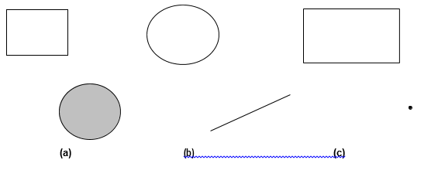
Figure F-2 – Examples of the DISJOINT relationship

- TOUCHES
Geometric object a intersects with geometric object b but they do not share interior points.
Only the boundary of one geometry intersects with the boundary or interior of another geometry.
The only thing the geometric objects have in common is contained in the union of their boundaries.
The ISO 19125-1 definition of TOUCHES is:
a.Touch(b) ⇔ (I(a)∩I(b) = ∅) ∧ (a ∩ b) ≠∅
This translates to: a touches b if the intersection of the interior of a and the interior of b is the empty set AND the intersection of a and b is not the empty set.
Note: This operator applies to the Area/Area, Line/Line, Line/Area, Point/Area and Point/Line relationships. It does not apply to a Point/Point relationship since points do not have a boundary.

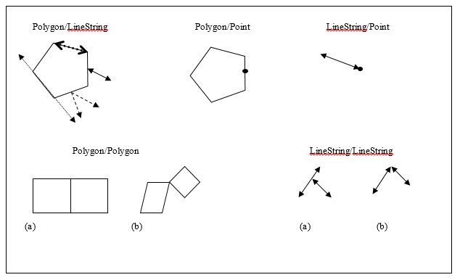
Figure F-3 – Examples of the TOUCHES relationship
Note the Polygon touches Polygon example (a) is also a case where the Polygon boundaries are COINCIDENT. In the Polygon/LineString example two of the LineStrings that share a linear portion of the Polygon boundary are also COINCIDENT with the Polygon boundary.
- WITHIN
Geometric object a is completely contained in geometric object b.
WITHIN includes EQUALS.
The definition of WITHIN is:
a. Within(b) ⇔ (a ∩ b = a) ∧ (I(a) ∩ I(b) ≠ ∅)
This translates to: a is within b if the intersection of a and b equals a AND the intersection of the interior of a and the interior of b is not the empty set.
Note that this formula matches the one given in the OpenGIS Simple Features Specification for SQL, Revision 1.1 (OpenGIS Project Document 99-049, Release Date: May 5, 1999) which is the precursor to ISO 19125-1.
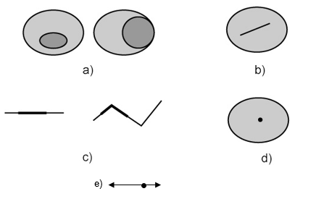
Figure F-4 – Examples of the WITHIN relationship — Polygon/Polygon (a), Polygon/LineString (b), LineString/LineString (c), Polygon/Point (d), and LineString/Point (e)
Note that a Line that completely falls on a Polygon boundary is not WITHIN the Polygon, it TOUCHES it. In that case it would also be COINCIDENT with the Polygon boundary and COVERED_BY the Polygon.
- OVERLAPS
The intersection of two geometric objects with the same dimension results in an object of the same dimension but is different from both of them.
For two Polygons or two LineStrings, part of each geometry, but not all, is shared with the other.
The OVERLAPS relationship is defined for Area/Area and Line/Line relationships. Points are either equal or disjoint.
Note that this does not include lines that cross.
The ISO 19125-1 definition of OVERLAPS is:
a.Overlaps(b) ⇔ (dim(I(a)) = dim(I(b)) = dim(I(a) ∩ I(b))) ∧ (a ∩ b ≠ a) ∧ (a ∩ b ≠ b)
This translates to: a OVERLAPS b if the geometric dimension of:
- the interior of a
- the interior of b
- the intersection of the interiors of a and b
are all equal AND the intersection of a and b does not equal either a or b.
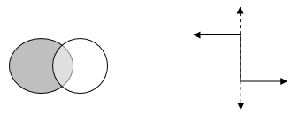
Figure F-6 – Examples of the OVERLAPS relationship
Note Lines that OVERLAP are also COINCIDENT.
- CROSSES
The intersection of geometric object a and geometric object b returns geometry with a dimension less than the largest dimension between a and b but is not the same as geometric object a or b.
Two LineStrings cross each other if they meet on an interior point. A LineString crosses a Polygon if the LineString is partly inside the Polygon and partly outside.
The definition of CROSSES is:
a.Cross(b) ⇔ (I(a) ∩ I(b) ≠∅) ∧ (dim(I(a) ∩ I(b)) < max(dim(I(a)), dim(I(b)))) ∧ (a ∩ b ≠a ) ∧ (a ∩ b ≠b)
This translates to: a crosses b if the intersection of the interiors of a and b is not the empty set AND the dimension of the result of the intersection of the interiors of a and b is less than the largest dimension between the interiors of a and b AND the intersection of a and b does not equal either a or b.
Note that “(I(a) ∩ I(b) ≠∅) ∧ “ was added to the beginning of the ISO 19125-1 formula so that it would not be true for disjoint geometry.
The CROSSES operator only applies Line/Line and Line/Area relationships.
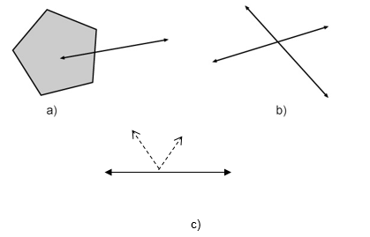
Figure F-7 – Examples of the CROSSES relationship
Note that example c) shows one solid line and one dashed line – their interiors intersect. If any Line were split into two separate Line features at the intersection point then the relationship would be TOUCHES because a boundary would be involved.
- INTERSECTS
is the reciprocal of DISJOINT.
The two geometric objects cross, overlap or touch, or one is within (or is contained by) the other. They have at least one common point.
- CONTAINS
is the reciprocal of WITHIN.
Given two geometric objects, a and b, if a is within b then b must contain a.
- COVERED_BY
(not a standard ISO 19125-1 operator)
No point of geometry a is outside geometry b.
The definition of COVERED_BY is:
a. COVERED_BY (b) ⇔ (a ∩ b = a)

This translates to: a is COVERED_BY b if the intersection of a and b equals a.
The following expressions are equivalent to a is COVERED_BY b:
- Polygon (a) is COVERED_BY Polygon (b): Polygon a is WITHIN a polygon b (WITHIN includes EQUALS)
- Point (a) is COVERED_BY Polygon (b): Point a is WITHIN or TOUCHES polygon b
- Line (a) is COVERED_BY Polygon (b): Line a is WITHIN polygon b or WITHIN the boundary of Polygon b
- Line (a) is COVERED_BY Line (b): Line a is WITHIN Line b (WITHIN includes EQUALS)
- Point (a) is COVERED_BY Line (b): Point a is WITHIN or TOUCHES Line b
- Point (a) is COVERED_BY Poiint (b): Point a EQUALS Point b
Note that the figure below on the left is an example of Lines that are COVERED_BY a polygon.
The figure on the right is NOT an example of a Line that is covered by a Polygon – it is an example of a Line that TOUCHES a Polygon. In both cases the Lines are COINCIDENT with the Polygon boundary.
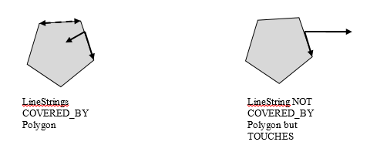
Figure F-8 – COVERED_BY relationship

- COVERS
(not a standard ISO 19125-1 operator)
COVERS is the reciprocal of COVERED_BY.
Given two geometric objects, a and b, if a is COVERED_BY b then b must cover a. COINCIDENT
(not an ISO 19125-1 operator)
- COINCIDENT
Two geometric Lines OVERLAP or one geometric Line is WITHIN the other. Note that EQUAL Lines are also COINCIDENT by this definition.
The intersection of two geometric Lines results in one or more Lines.
This operator is only to be used to compare a Line with another Line. Note that normally the boundary of a Polygon is not the same as a Line but for this operation the boundary of a Polygon, exterior and interior rings, is treated as Lines for the COINCIDENT test.
The following expressions are equivalent to a is COINCIDENT with b:
1. Polygon (a) is COINCIDENT with Polygon (b): The boundary of Polygon a OVERLAPS or is WITHIN the boundary of Polygon b.
2. Line (a) is COINCIDENT WITH Polygon (b): Line a OVERLAPS or is WITHIN the boundary of Polygon b.
3. Line (a) is COINCIDENT WITH Line (b): Line a OVERLAPS or is WITHIN Line b
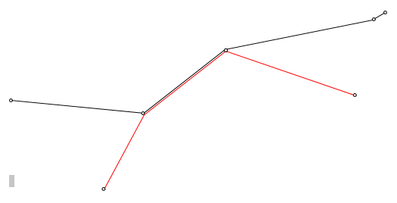
Figure F-9 – Example of COINCIDENT relationship (line geometry)
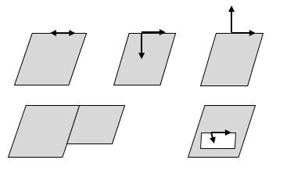
Figure F-10 – Example of COINCIDENT relationship (polygon boundary)
Above are other examples of objects COINCIDENT with the boundary of a Polygon. LineStrings following a portion of a Polygon boundary or Polygons sharing a boundaryportion.
Note that by definition a Line can be COINCIDENT with an interior boundary of a Polygon.
Note that other relationships may also be true such as COVERED_BY or TOUCHES since COINCIDENT is not mutually exclusive.

Page intentionally left blank

